**Sri Lankan Institute of Information Technology**



**Application Framework - SE3040**

**Year 3, Semester 1 (2020)**

**ONLINE SHOPPING CART SYSTEM FOR A FASHION STORE**

|  |  |
| --- | --- |
| **ID Number** | **Name** |
| **IT18045918** | **Akalanka P.K.G.C** |
| **IT18051612** | **Rajapaksha H.M.U.D** |
| **IT18078510** | **Vidhanaarachchi S.P** |
| **IT18051780** | **Gunasekara R.P.T.I** |

# **Abstract**

This report discusses our expertise in designing Online Shopping Cart System software solution for a fashion store.

The program was designed to accomplish the concept for a Fashion store's online shopping cart system. This system's main intention is to make things more convenient to maintain by deploying a fully automated system with all required functionalities for everyone as a whole. In comparison, the other significant aspect is that most moderate techniques are used on the system. With this method, user information, shopping cart, admin information, manager information can be handled. In fact, the program has a capability of sending data across related positions [user, admin, store manager] as well as notifying the transaction adjustments.

All those necessary functions can be solved straightforwardly by using this system solution. Overall the fashion store system is equipped with an effective, appealing, simple and moderate framework. It would help fix the issues and have a good shopping experience without any inconvenience.

# **Acknowledgement**

As a group, we wish to convey our heartfelt gratitude to all those who brought us the possibility to effectively complete the project. Special gratitude to our AF Lecturer Mr Prasan Yapa, whose commitment to the enhancement and motivation of suggestions helped us to organize our project, especially with the implementation of the new system

We would also like to acknowledge with great gratitude the vital role played by Mr. Thusithanjana Thilakarthnai, who provided us a lot of encouragement to render our project a good one during the semester by offering us advice and feedback.

Last but not least, a lot of thanks go to everyone whose names are not listed above, has helped us to make this project a success in various ways.

# **Tasks and Responsibilities Table**

|  |  |  |
| --- | --- | --- |
| **IT Number** | **Name** | **Responsible Role** |
| **IT18045918** | **Akalanka P.K.G.C** | **Item Management System** |
| **IT18051612** | **Rajapaksha H.M.U.D** | **Order Management System** |
| **IT18078510** | **Vidhanaarachchi S.P** | **User Management System** |
| **IT18051780** | **Gunasekara R.P.T.I** | **Store Management System** |

# **Introduction**

"Online shopping cart system for a fashion store" called GSTD Fashions, is an immersive software application for online shopping. The system supports the three roles namely user roles, the role of administrator and the role of store manager. The administrator is allowed to create categories and to add to the system sore mangers. Two types of administers names Admin and Store Manager is responsible in handling the GSTD web application. Anyone can view products as a guest even without login to the system. But, only users who have logged into the system are allowed to place orders. The admin can add new admins as well as store managers into the system. Admin as an item management role can create categories for the products while the store manager can add products with details to the relevant category with discounts.

Through user management users are given the facility to add products to the shopping cart as well as purchase the selected products in the shopping cart by selecting the payment method (card/cash on delivery, etc.).They can create a wish list and rate the displayed products as well. The system is developed using proper.

The fully functional system was built which can be described as the most suitable solution for the fashion store. This application was built around the following technology stack.

1. React
2. MongoDB
3. NodeJS
4. Express
5. Springboot

# **High Level Diagram**

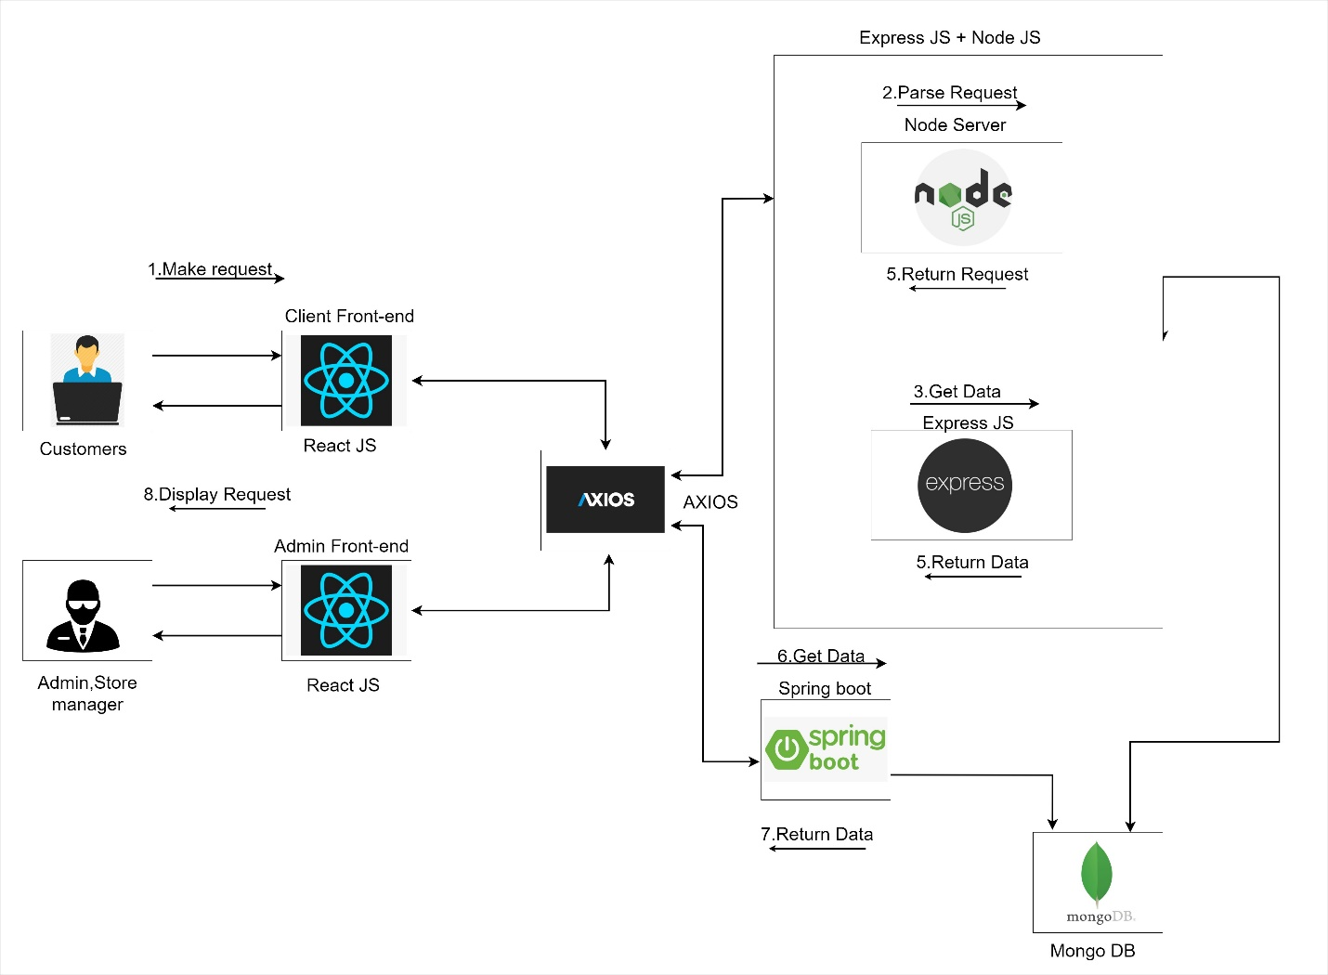

# **User Management**

There are two ways in which users are managed in the system.

1. Client Side
2. Admin Side

## **Client Side**

The user can register into our system. View the items available, purchase or add those items into the cart. The user can also maintain a profile on themselves. They can also send feedbacks to the admin regarding their thoughts and complaints. Users can also edit their details and delete their account if they want to.

The user has the privilege to view the items available in the system even without been logged in.

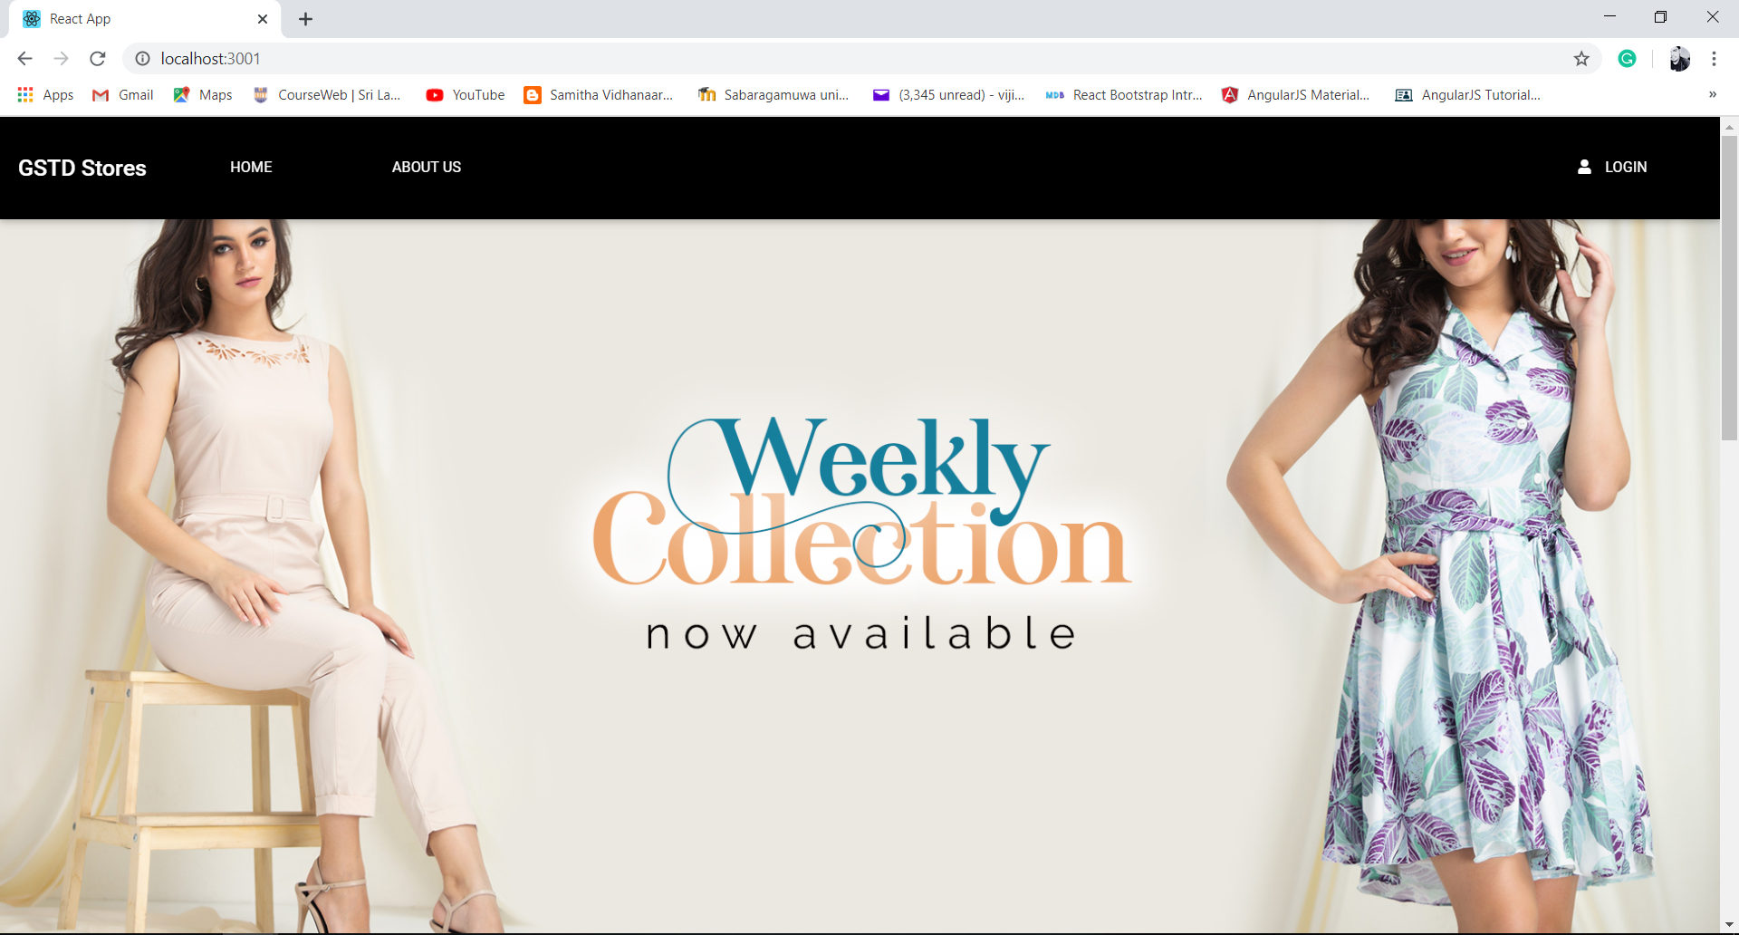

He/she can view all the products available their ratings and comments as well as the details of the shop through the about us page.

**Login Page**

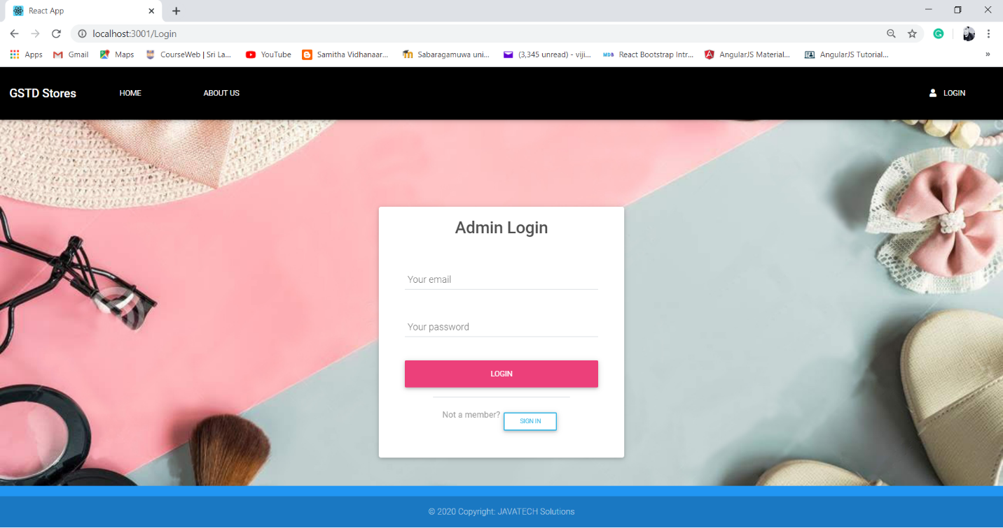

Anyone can view products as a guest without login to the page. But, if a customer wishes to place an order they must log in to the website. If the customer is already registered, he/she can log in using this page which can be accessed from the right upper corner navigation button. To log in the customer must enter their email address as well as the password.

If a user enters a wrong password or an email an error message is been displayed.

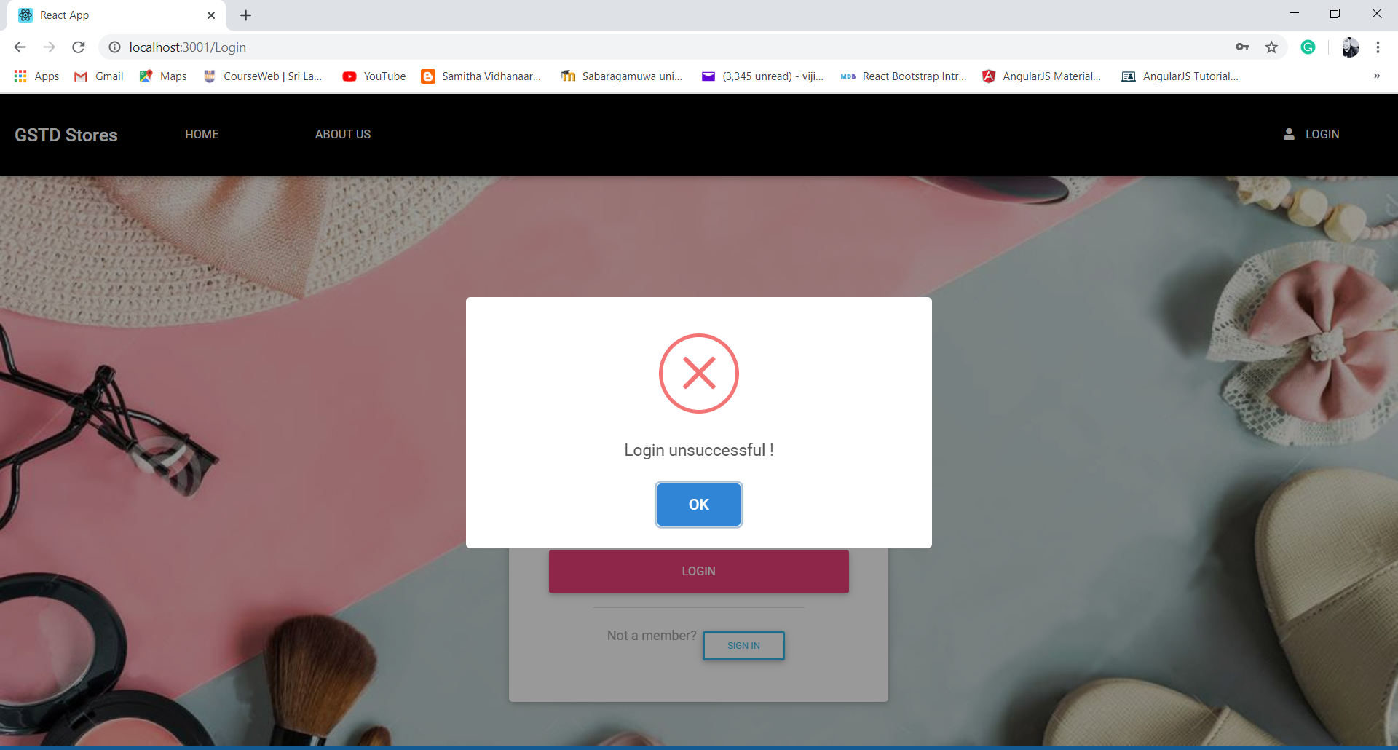

If the user enters the correct credentials, the system will validate the user and let user to visit the site and place orders.

When the login is successful, profile, cart and the wish list will appear on the navigation bar.

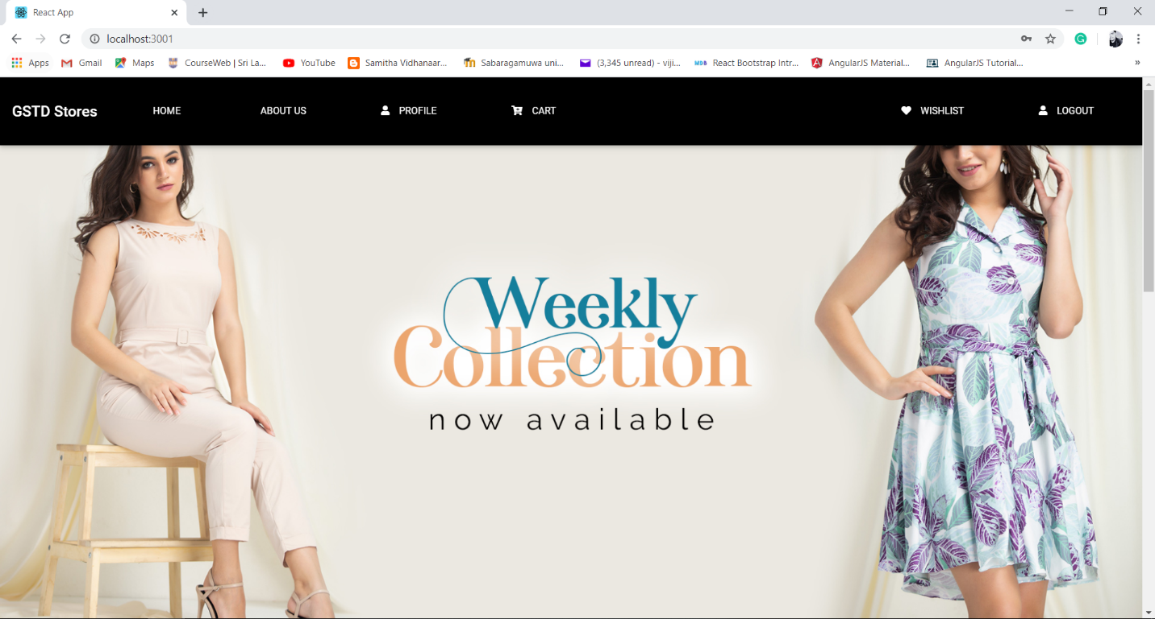

If a customer is not registered, he/she can register by clicking the sign in button.

**Register Page**

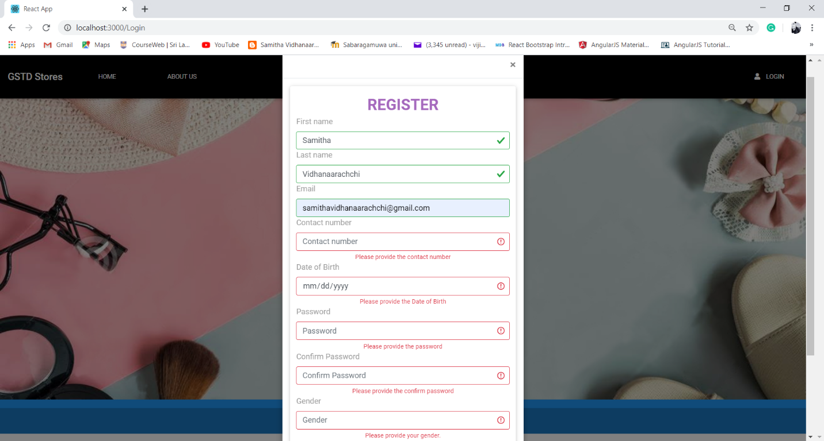

Customers can register using this page. All the fields are being validated therefore, the customer needs to enter all the required fields.

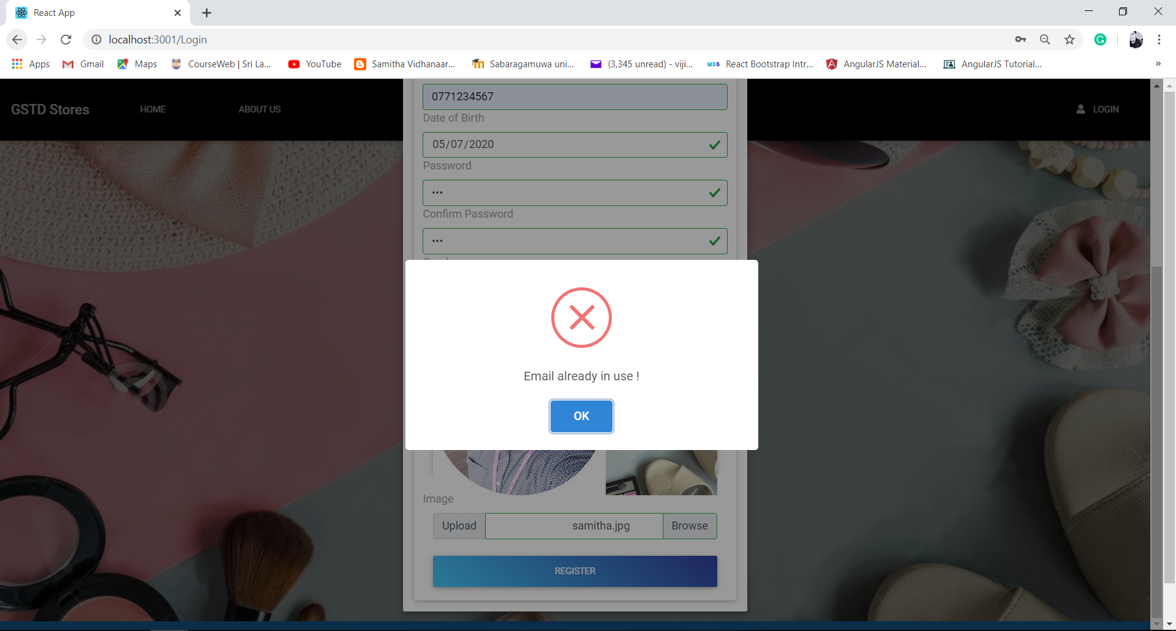

Customers cannot enter an email which is already been used because of authentication reasons.

After inserting all the details correctly with an image, by clicking the register button a customer can register into the system. If the entered details satisfy the validations, the system will display a successful message by registering the customer.

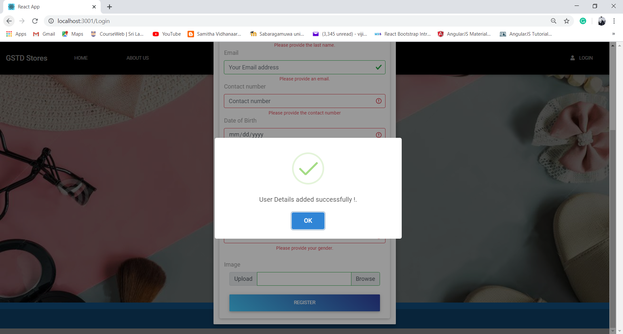

**Profile Page**

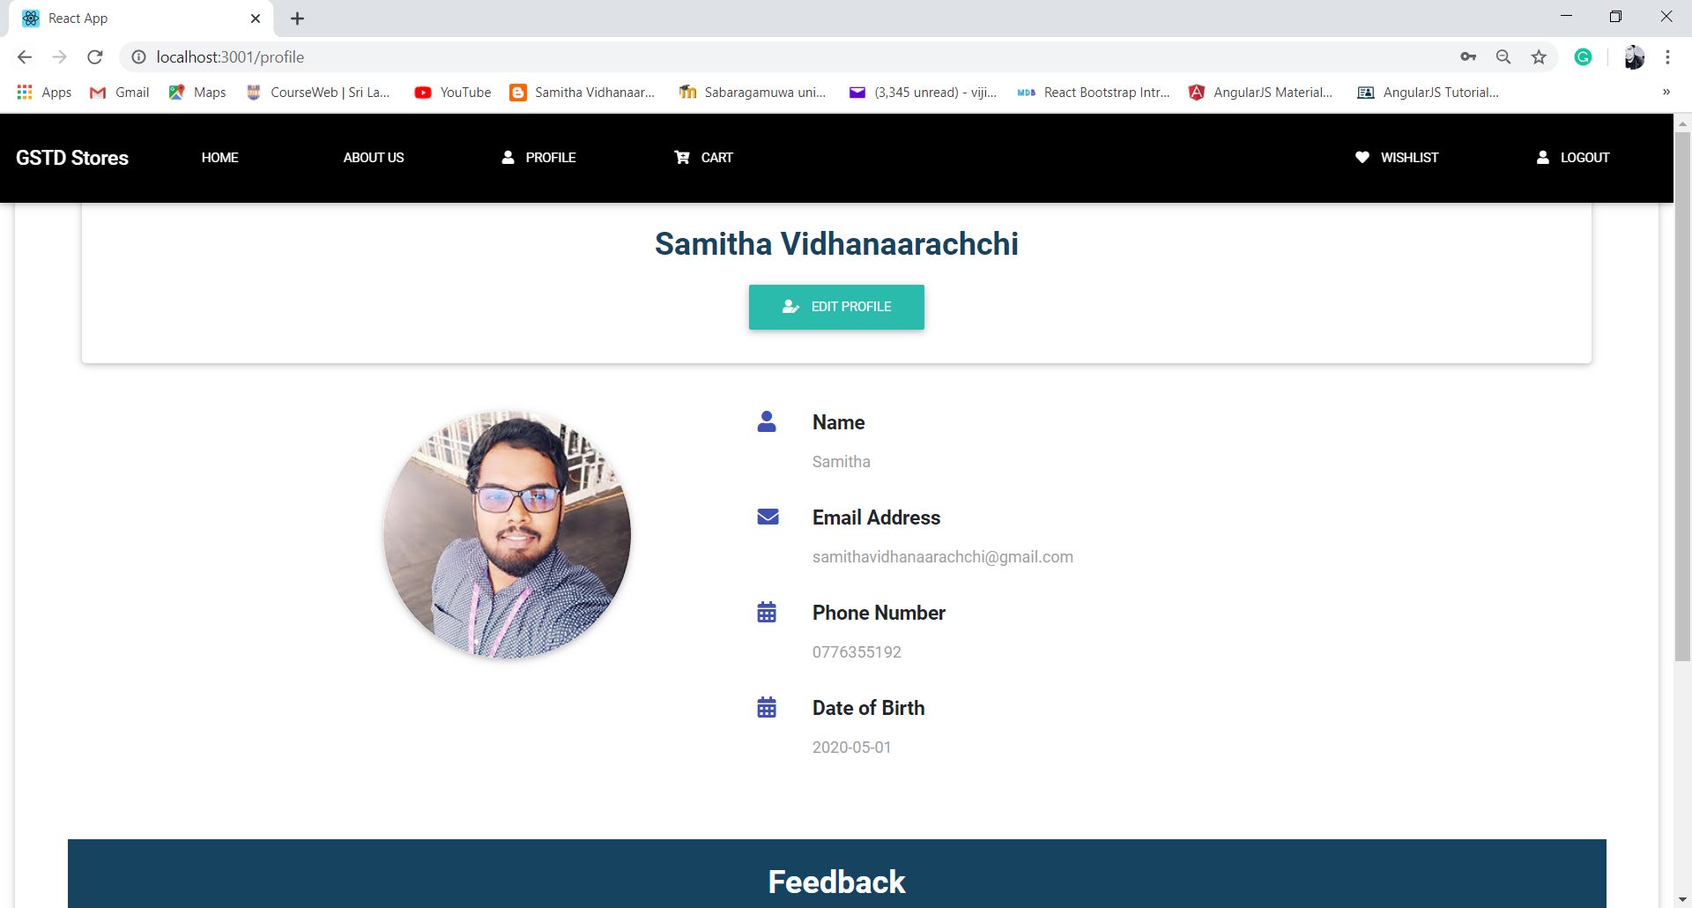After log in the customers can view and order products as they please. Also, they have their own account which displays their details. This page can be accessed through the profile button in the navigation

Also customers have the opportunity to express their ideas and thoughts even complaints about anything through the feedback form that is available in the profile. Through this the administration will be able to get an idea of their service.

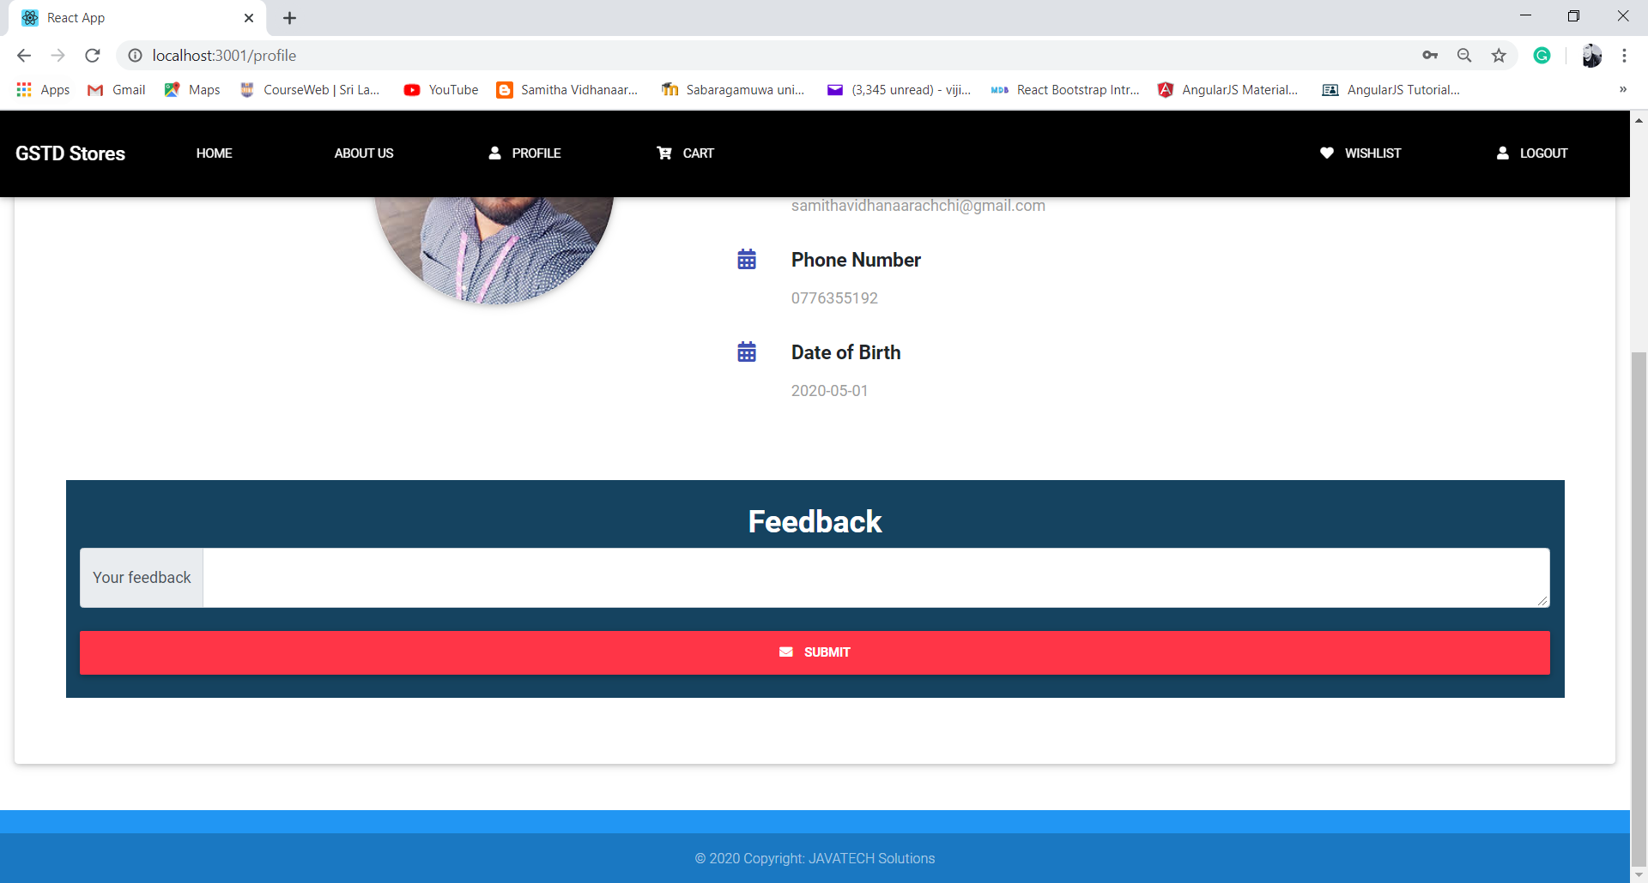

After adding a feedback, a confirmation message is being displayed to the customer.

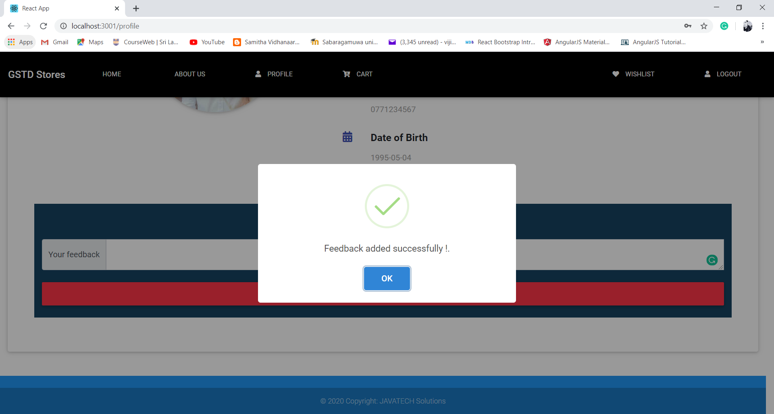

If the customer enters the submit button without a feedback an error message is displayed.

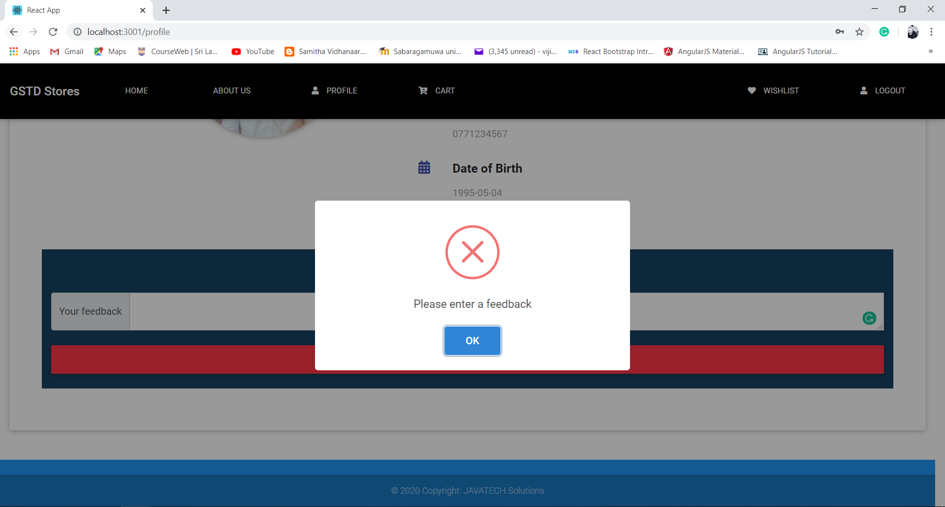

Customer can also update their details in their profile by clicking the “Edit profile” button. The page will redirect to the edit page which is shown below.

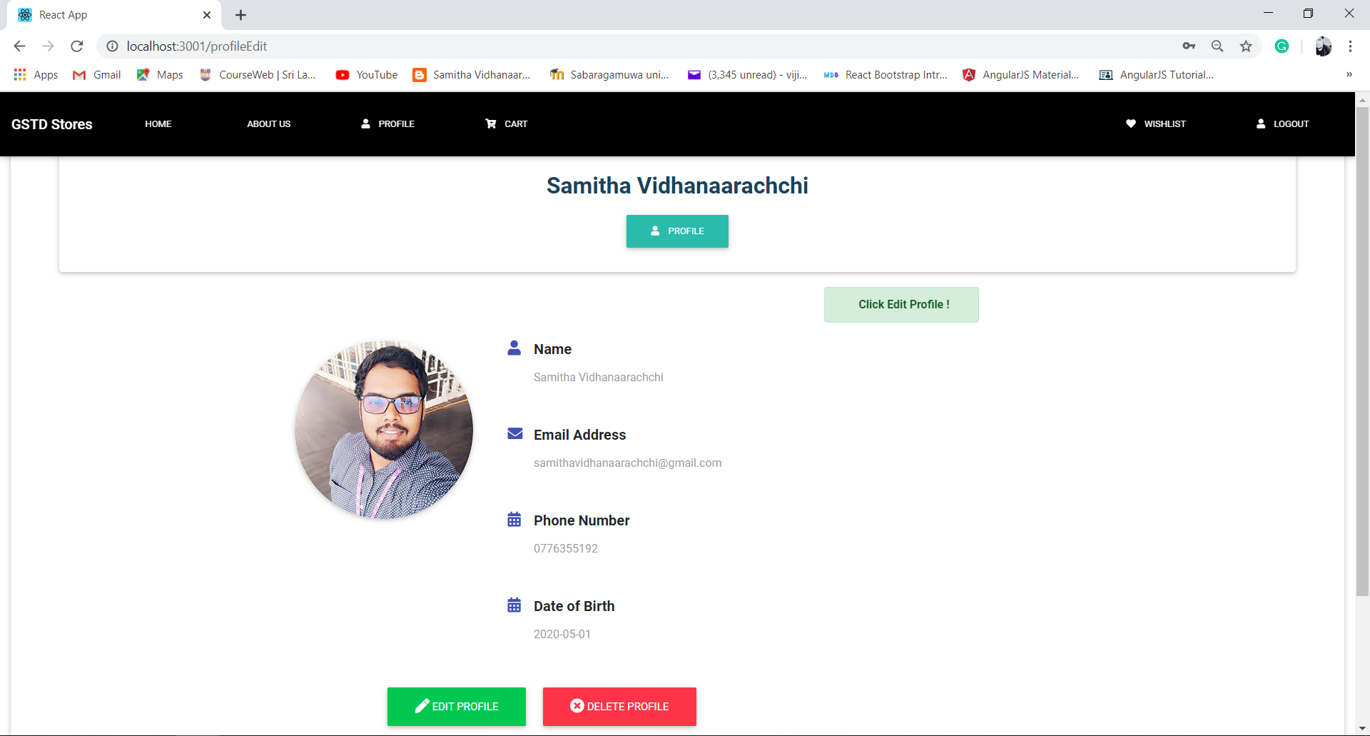

From this page if the customer clicks on “Edit Profile” the details will be loaded into a form where he/she can edit them. This feature makes the website attractive as well as user-friendly. Initially as shown in the above picture only an animation is displayed which says “Click Edit Profiles”.

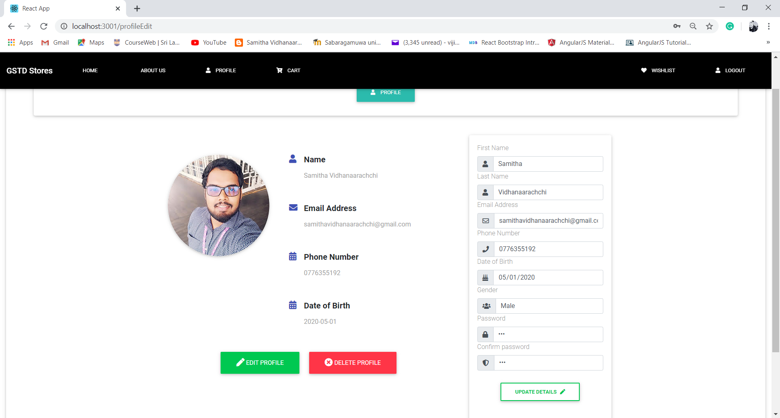

After editing the details, the customer will get a confirmation message saying that the update is successful. In here all the text fields are validated. All fields must be entered if not a warning tag is displayed.

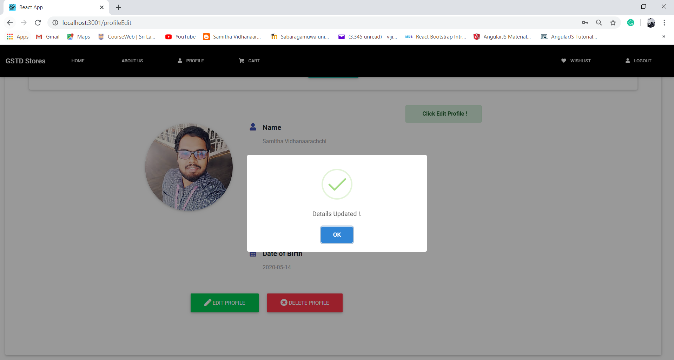

If the customer clicks on the “Delete Profile” button the system will display a confirmation button. If the customer confirms, the account will get deleted and the customer will get redirected to the login page.

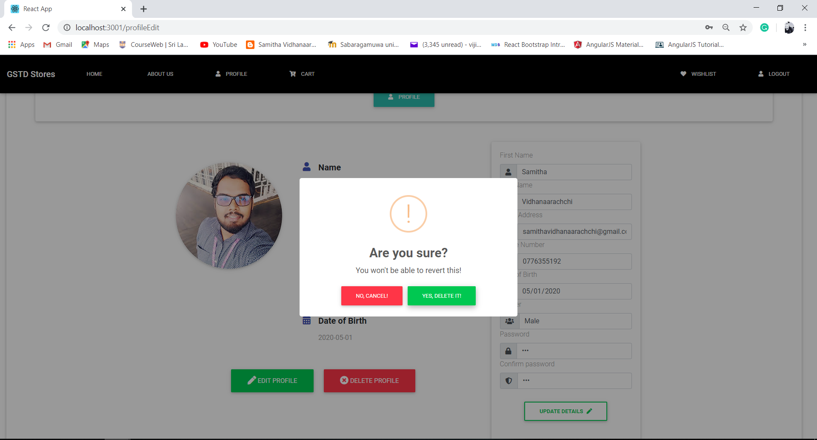After enjoying the online shopping experience, they can logout from the system. Session as well as security measures have been taken to prevent unauthorized actions

## **Admin Side**

Admins are of two types

1. Admin
2. Store Manager

**User Details Page**

Only the admin can log into the admin panel and view all the available customers who have been registered into the system. Store manager does not have the privilege to view and delete customers from the system. The admin can view the customers through each page separated by a pagination to make the website attractive and user-friendly as well as organized.

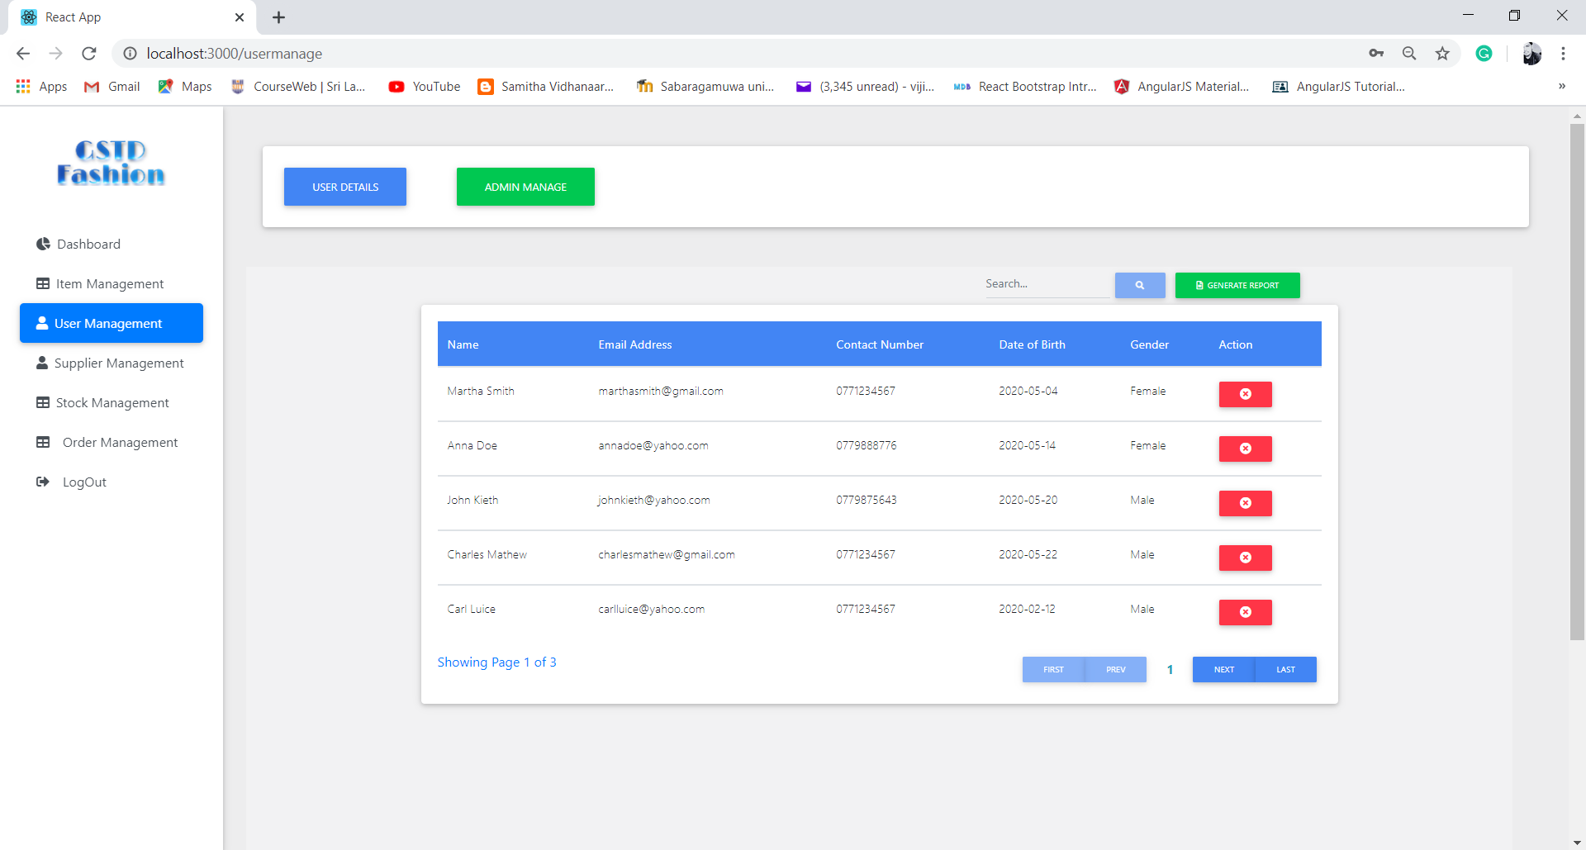

In this page, since there can be several customers as mentioned above only 5 customers are displayed in one page. Admin can click next or last in the pagination to view the customers.

The admin can also search any customer by his/her first name through the search bar. The records are sorted and displayed according to the name. After erasing the name it will again display all the details.

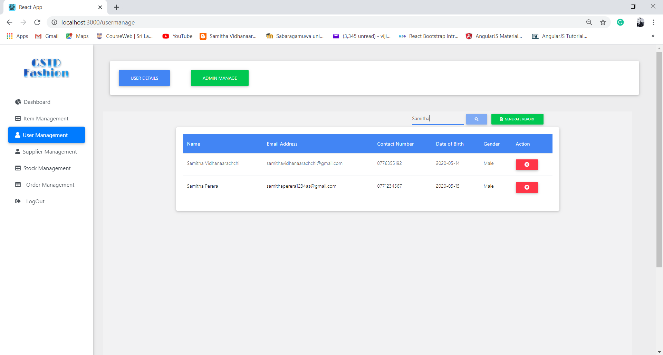

The admin can also generate a PDF to have a saved copy of the customer details by clicking the generate report button next to the search.

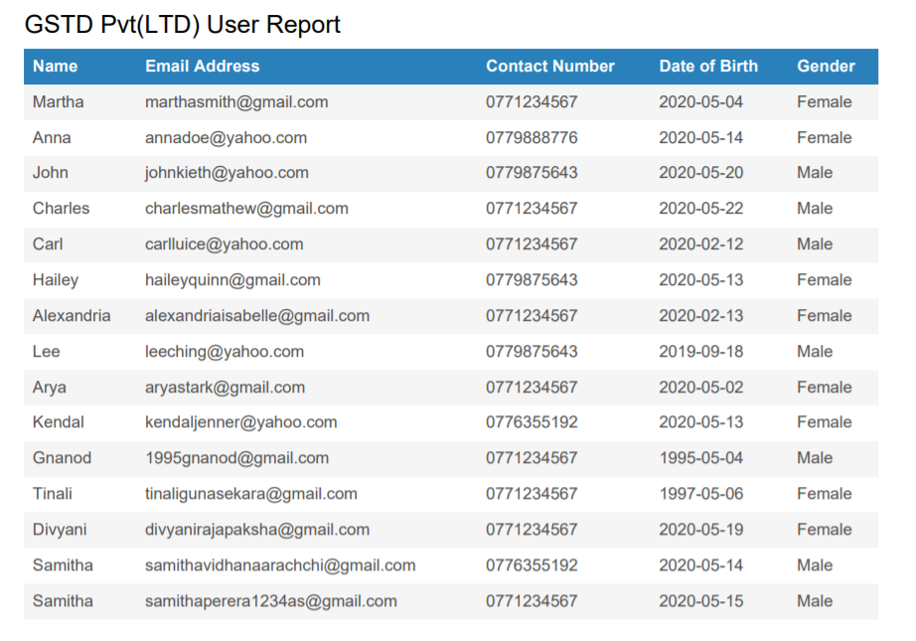

The admin has the capability to delete a customer but an email will be sent with the reason attached. We thought of adding that functionality because some users may not be appropriate to be as a customer. Before deleting a system displays a confirmation message to the admin to confirm their decision

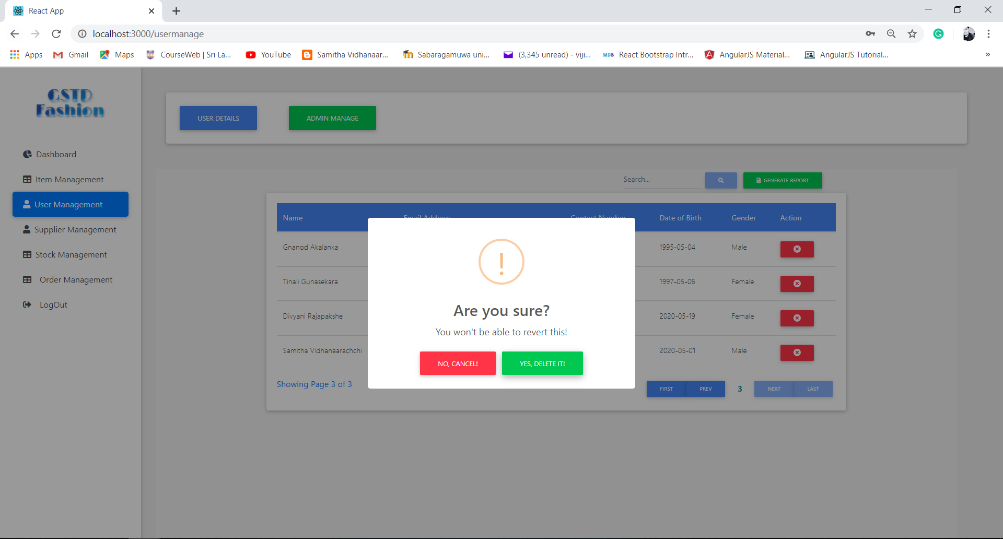

On upon the decision, the customer will be removed from the system. In the email sent, the reason as well as the contact details to which the customer can inquire is provided.

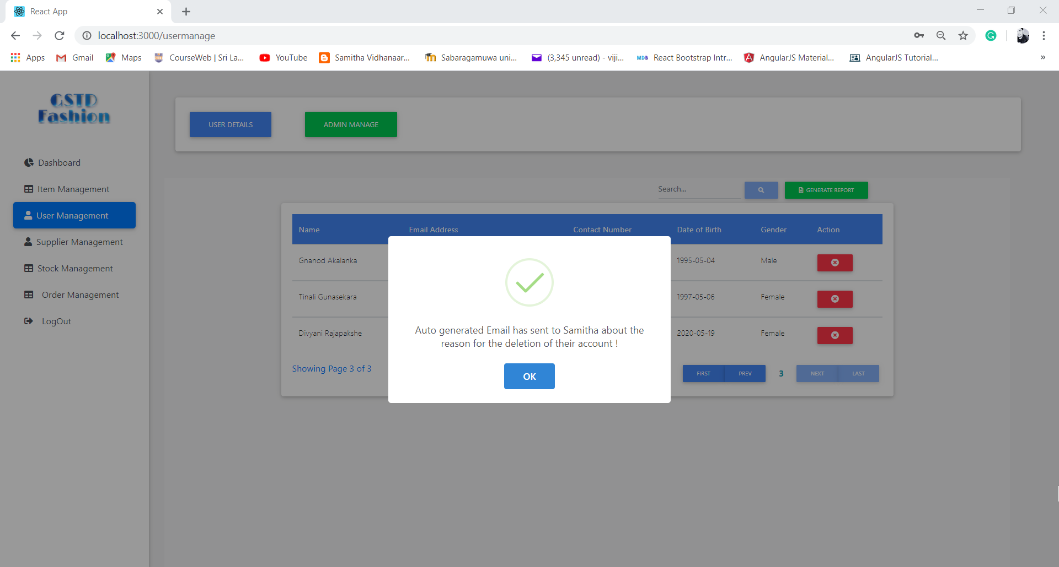

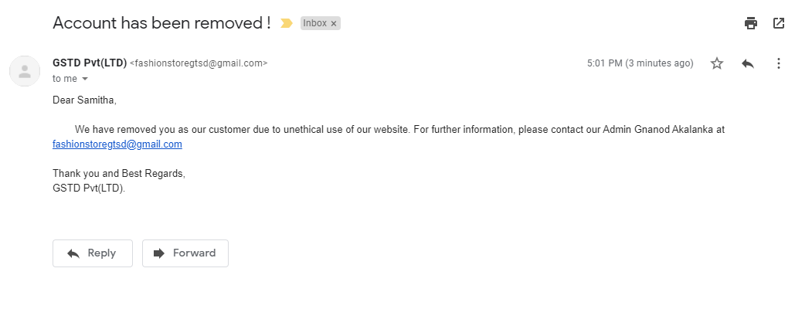

**Admin Manage Page**

The admin can also add, delete and edit the details of the Administrators available in the system. Two types can be only added. It can either be an “Admin” or a “store manager”. If the admin tries to add another position it is validated and the system displays an error message.

After adding an administrator, the details are displayed in the left table shown below.

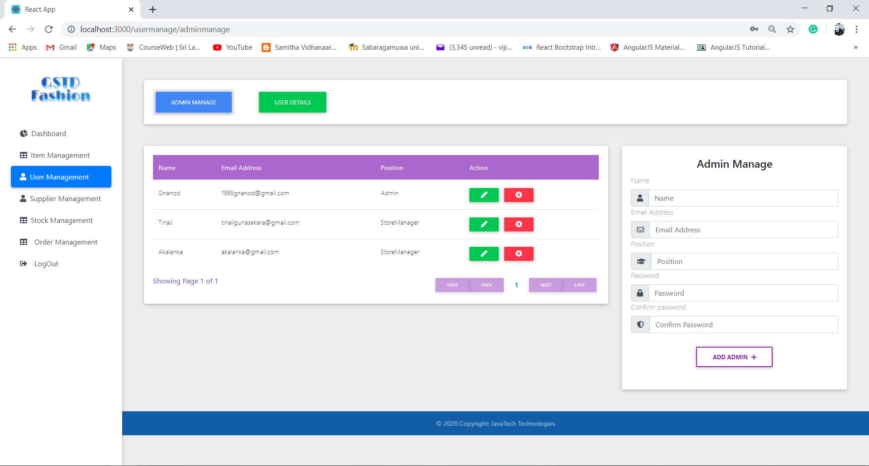

With adding an administrator an email is been sent to that relevant person congratulating on his new role.

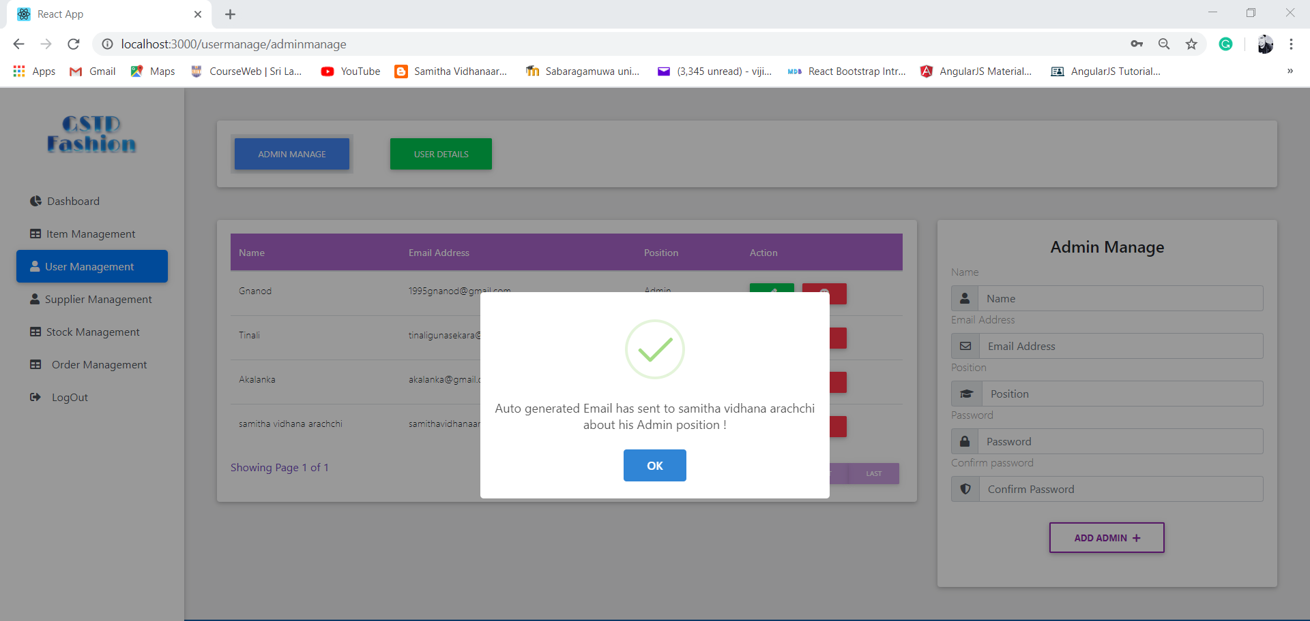

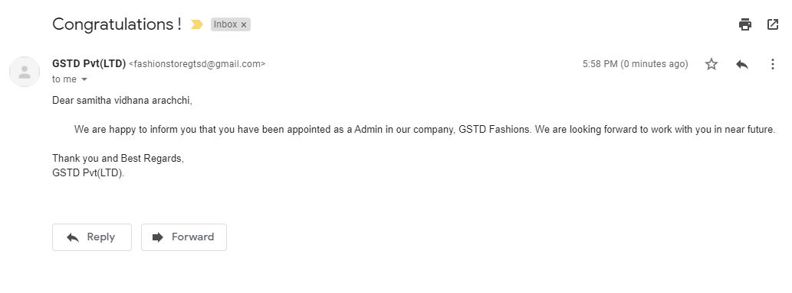

By clicking the edit button the details of the relevant administrator will get loaded to the form where the admin can edit the details. When that happens the add admin button will get changed to update admin making the system more attractive

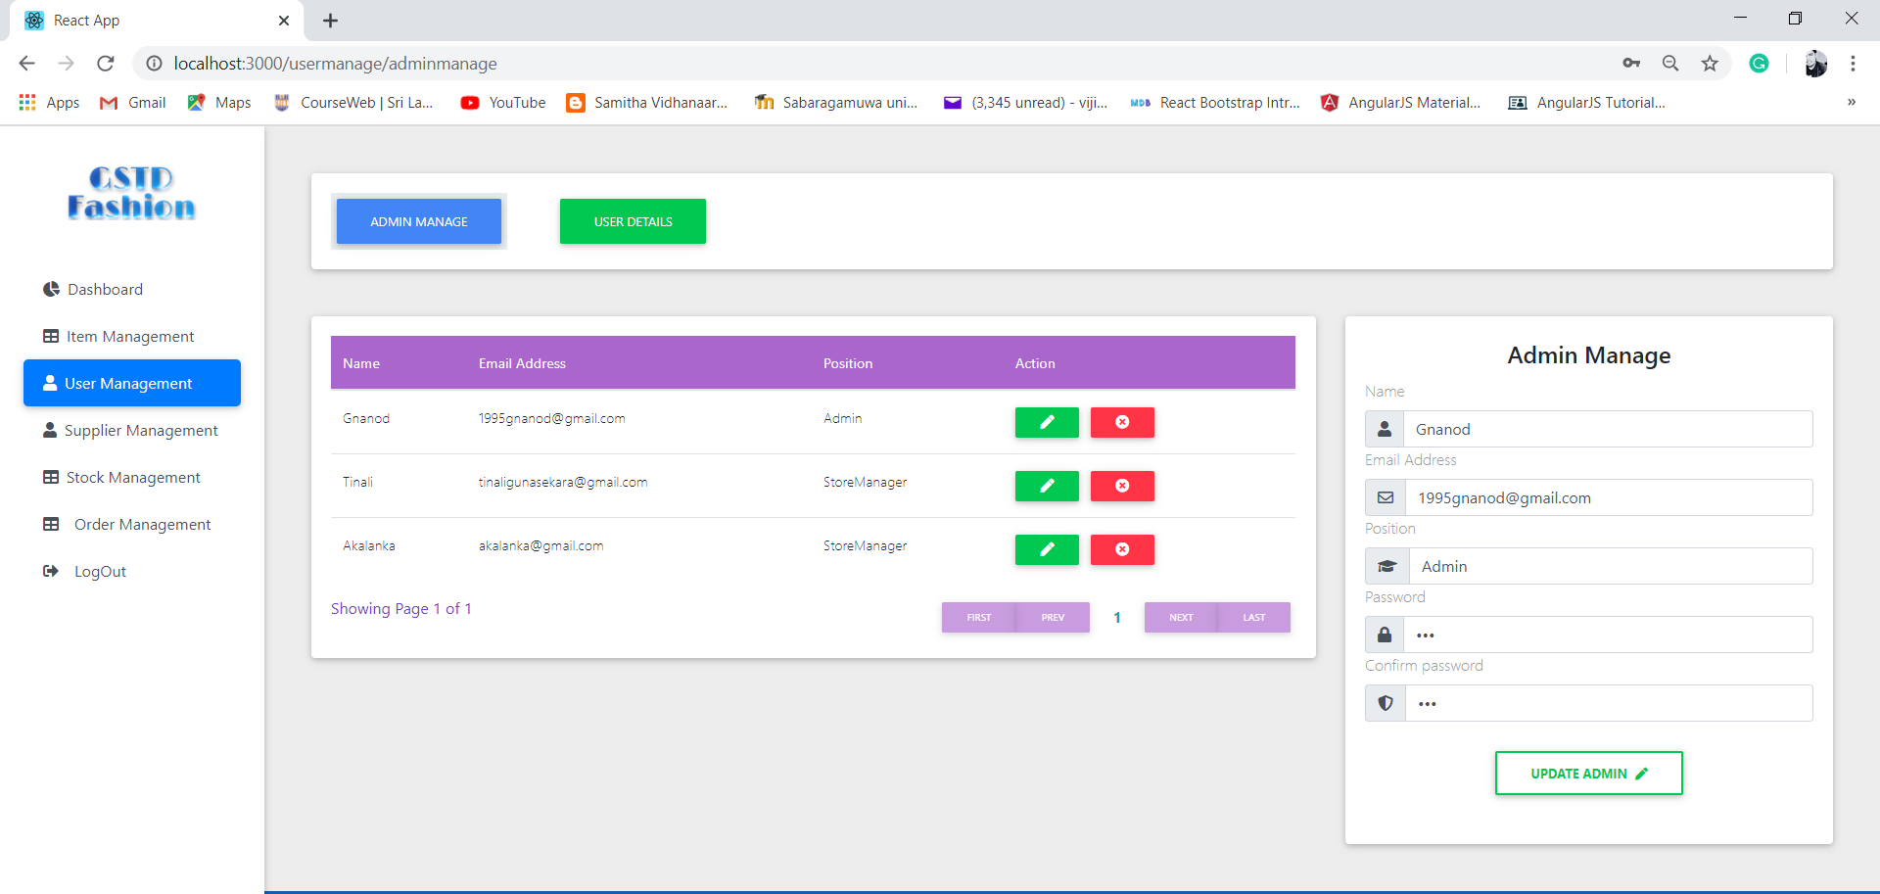

After editing the details admin can click on update admin button. If the details are according to correct validations a confirmation is been displayed.

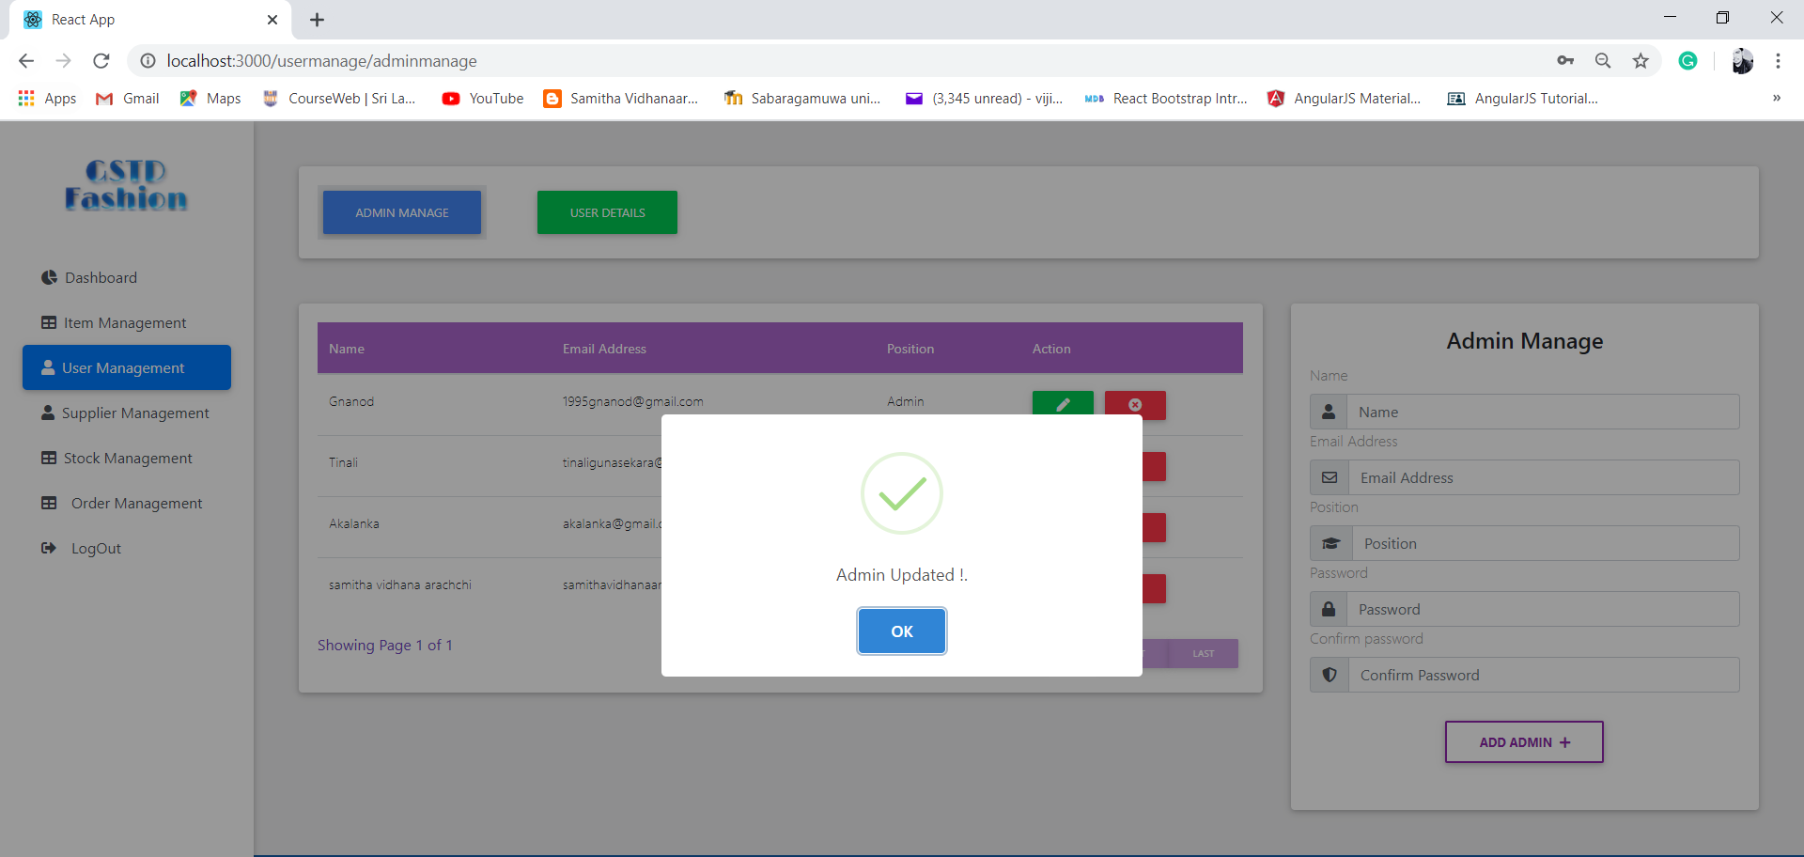

When deleting an administrator, the system displays a confirmation message. After confirming the admin will be removed from the system.

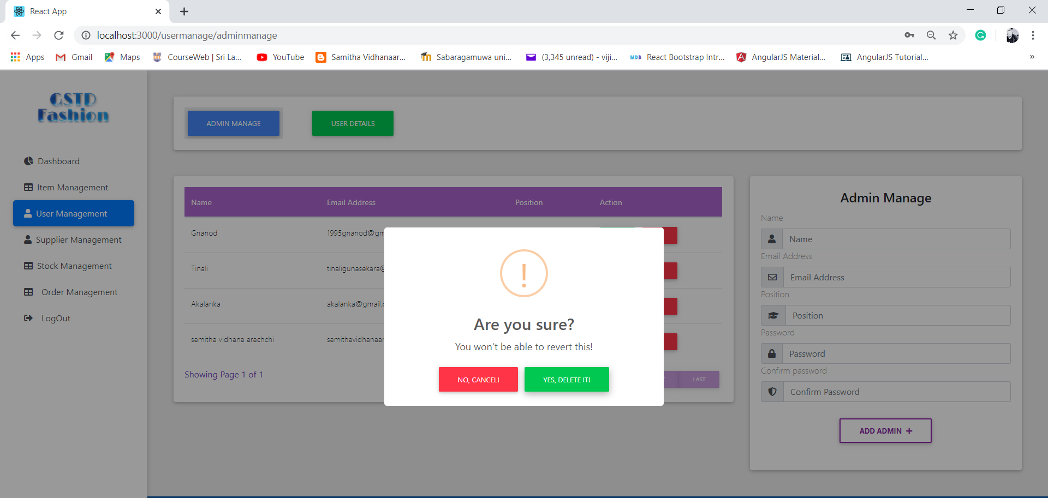

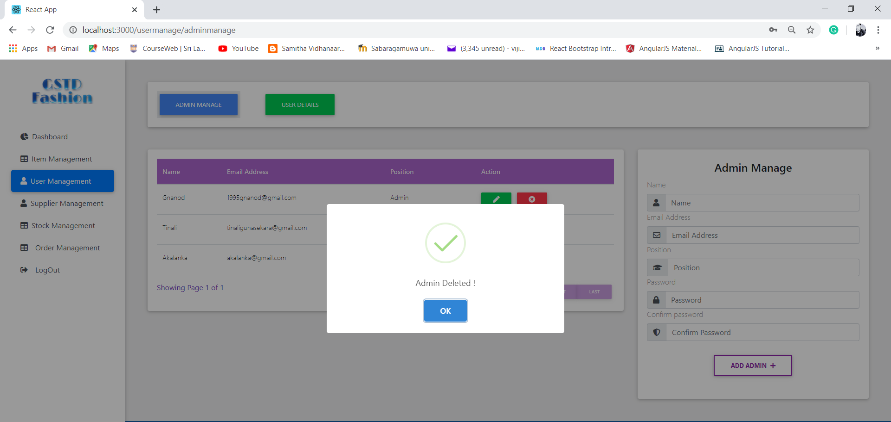

If the admin deletes the same record while that is still in the edited form, the form will change back to the initial state by clearing all the fields.

In order to have a successful system and an efficient website a data analysis is necessary. Therefore, a User analysis page is being displayed in the dashboard. In here a bar chart is displayed with the details of male and female count so that admin can get a clear idea about the interest of the different parties towards the website in order to scale their business.

Also the total number of sales, the total number of customers and the total number of suppliers are shown in a progress bar.

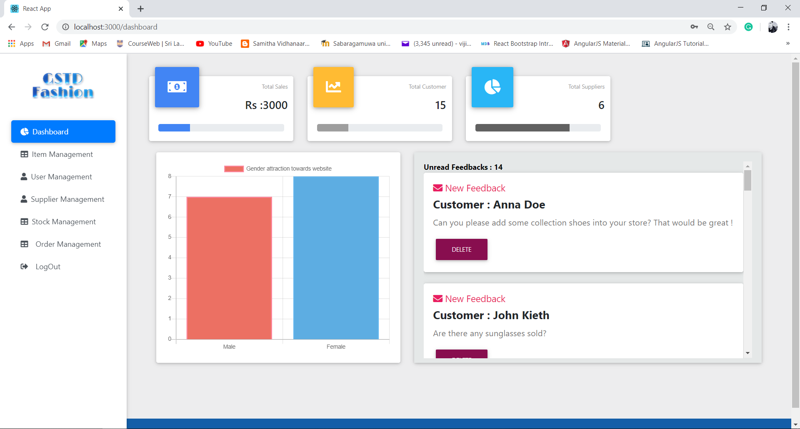

The dashboard can be viewed by both admin and supplier manager. They can view the feedback given by the customers/users. The unread feedback count number is also displayed at the top. Through this we thought the customers can interact with the admins, and the admins can have a knowledge about the customer’s thoughts to uplift their business.

Upon reading they can delete the feedbacks.

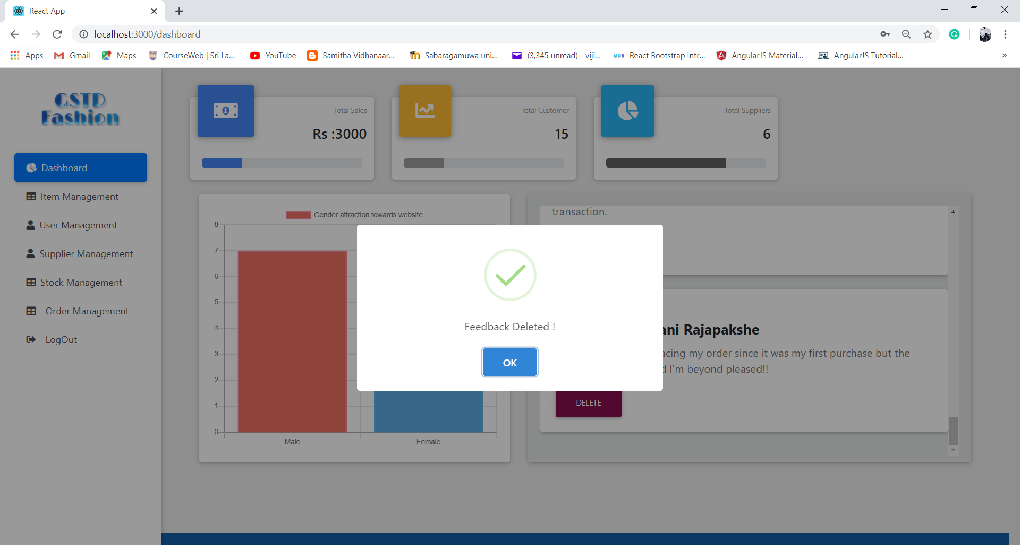

**Admin Login**

When the admin log in to the system it is displayed with the user management section and when a supplier manager logs into the system the user management section is not displayed.

Below is the way admin sees when he logs in to the system.

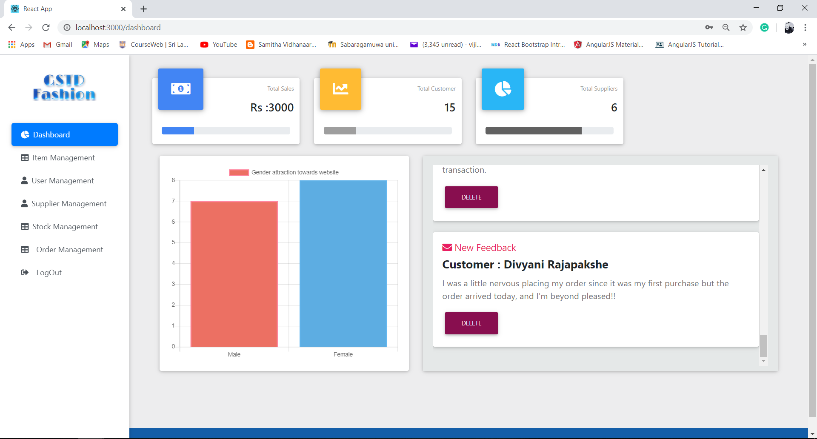

Below is the way supplier manager sees when he logs into the system

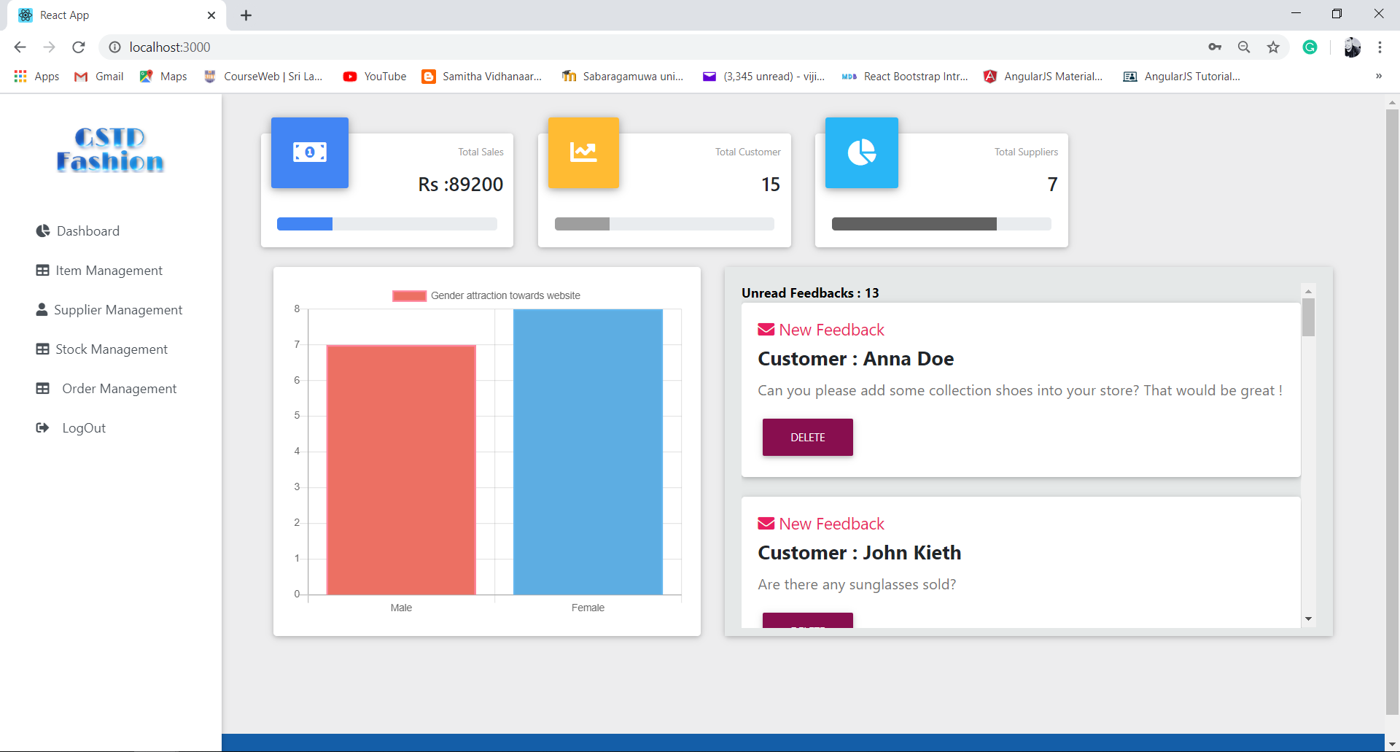

Admin can create categories for the products. The store manager can add products with details to the relevant category and add discounts to selected products.

Prior to inserting data, the user management pages are displayed as below

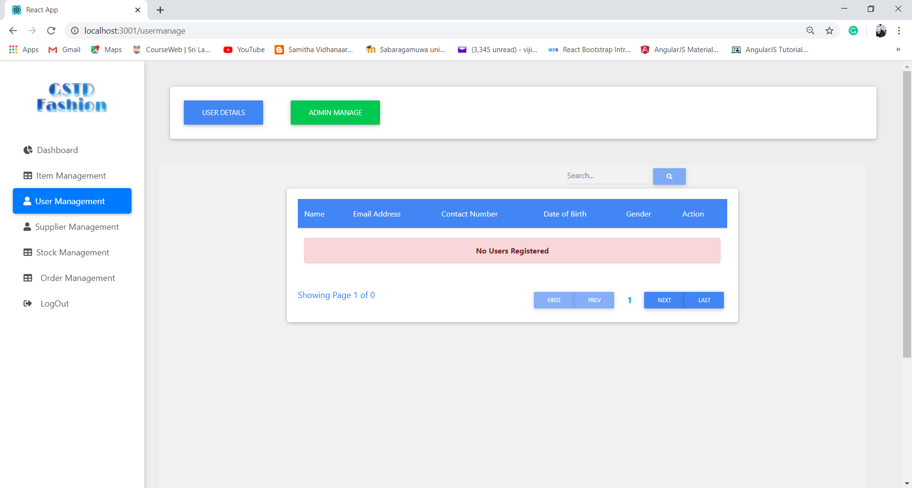

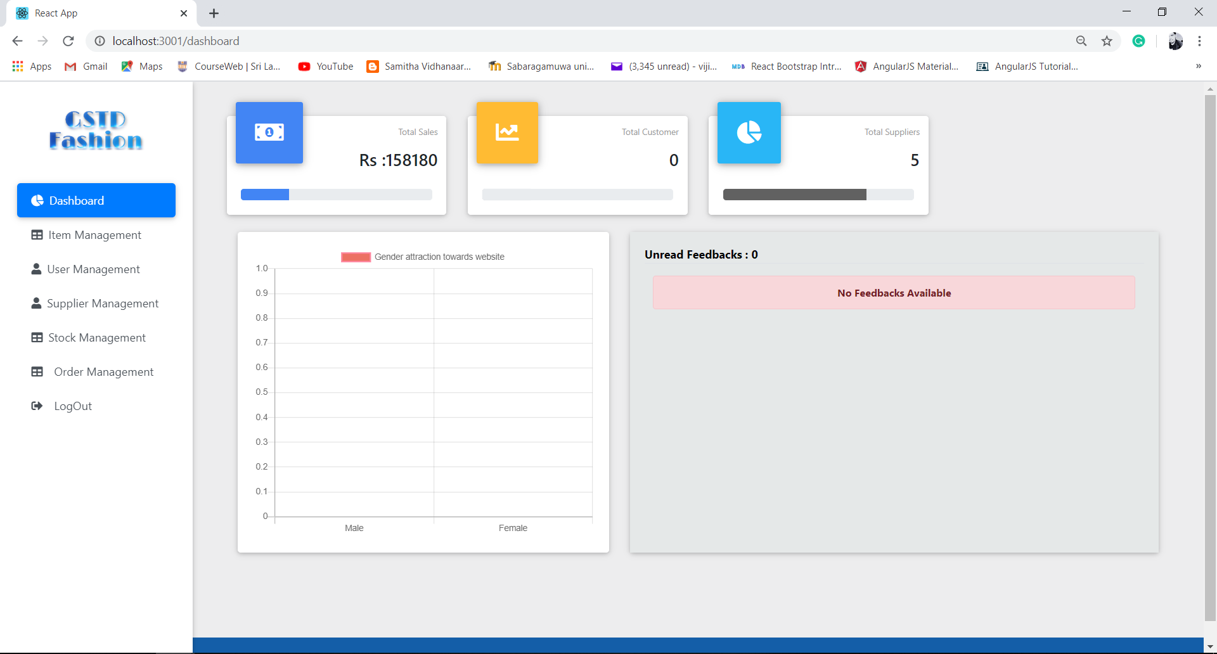

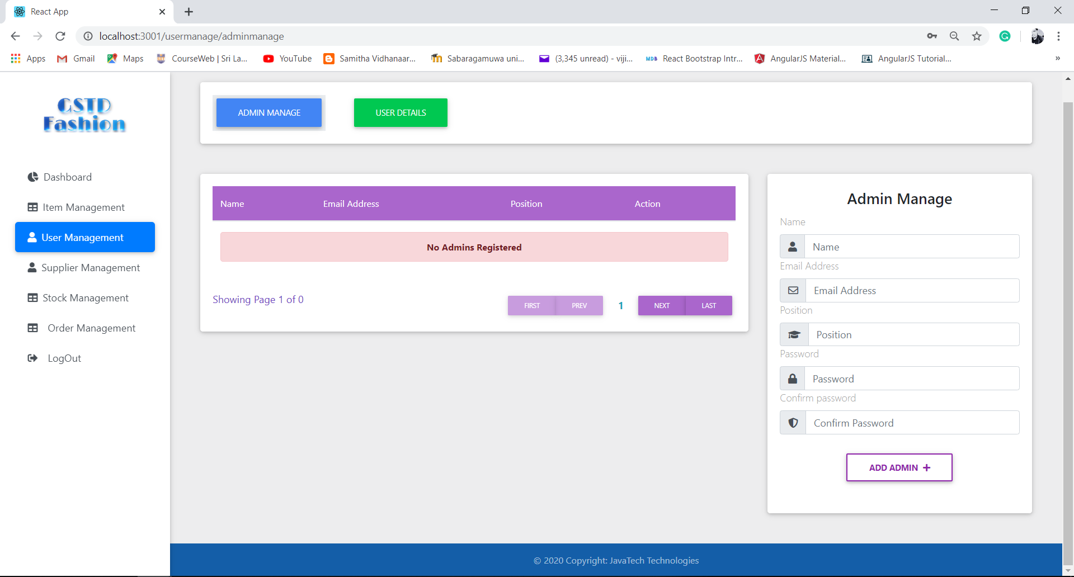

A tag is displayed saying that there are no records.

# **Item Management**

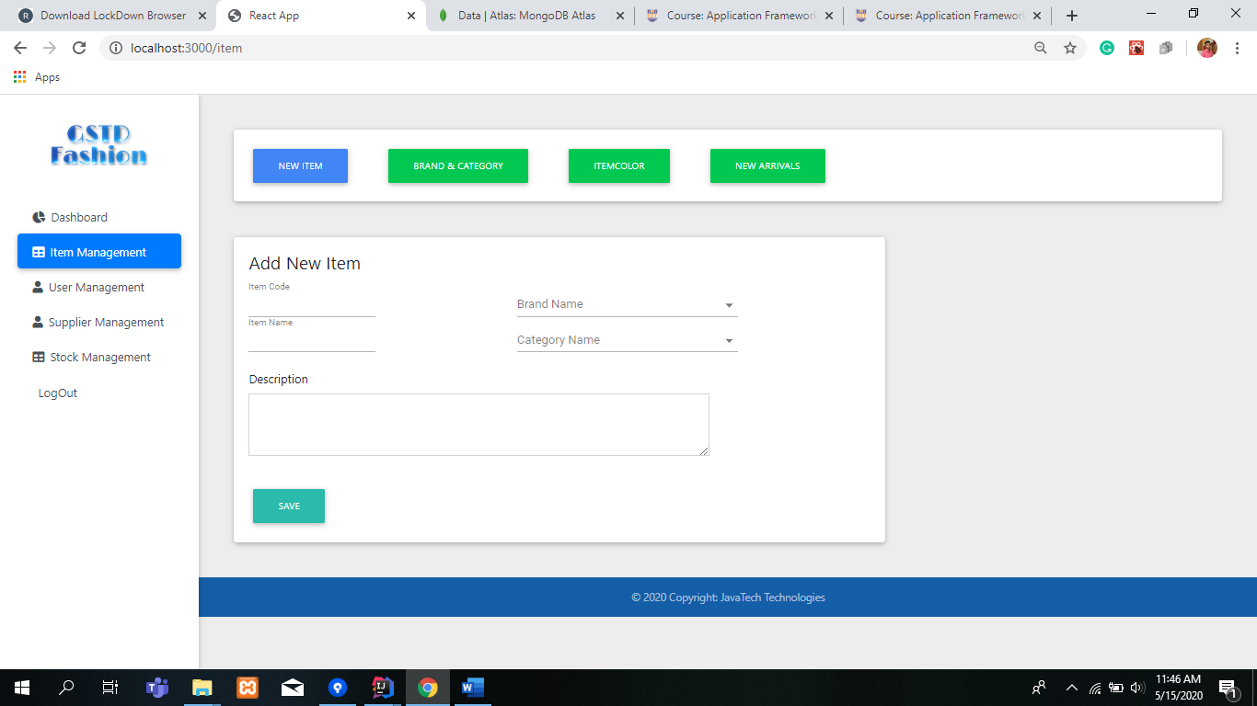

New Item Management function is responsible for keep tracking on Item Details. When Store Manager login to the application and he/she can add this item details to database. In this user Interface admin want to enter Item Code, item name, Item description and Also admin can choose brand name and category name using AutoCompletes. All the brand Names and Category Names have been loaded to the Auto Complete.

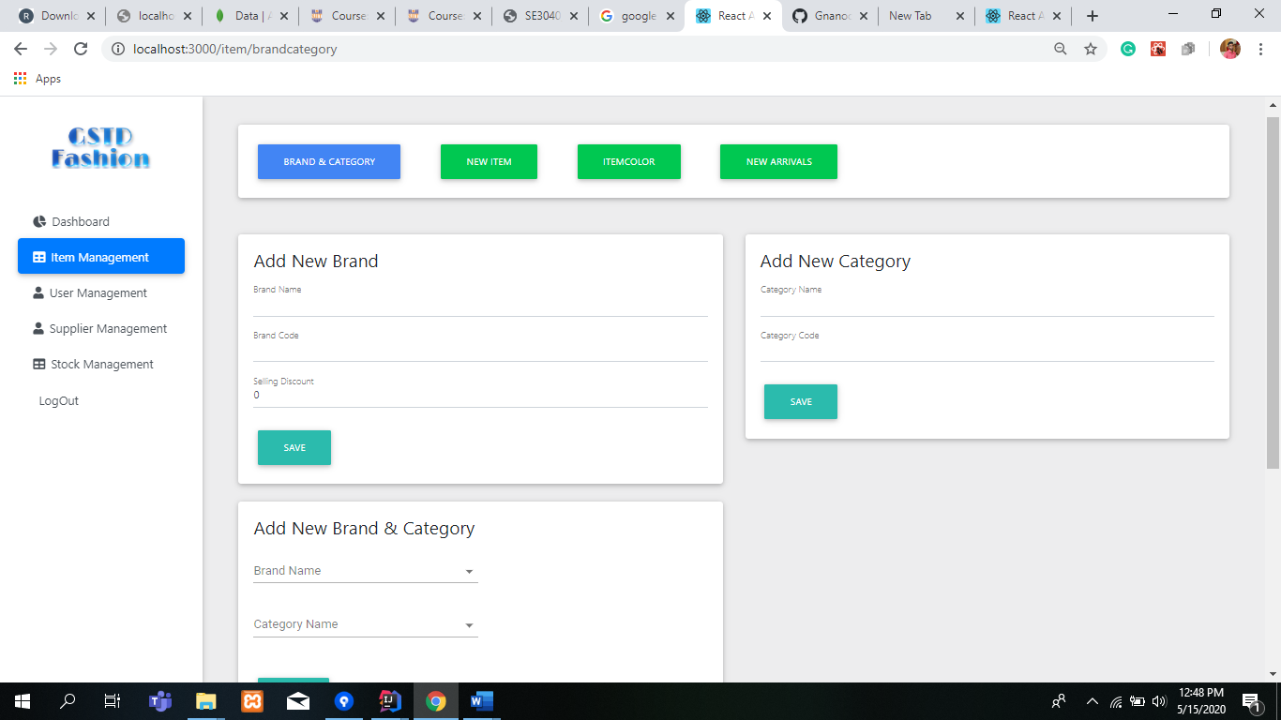

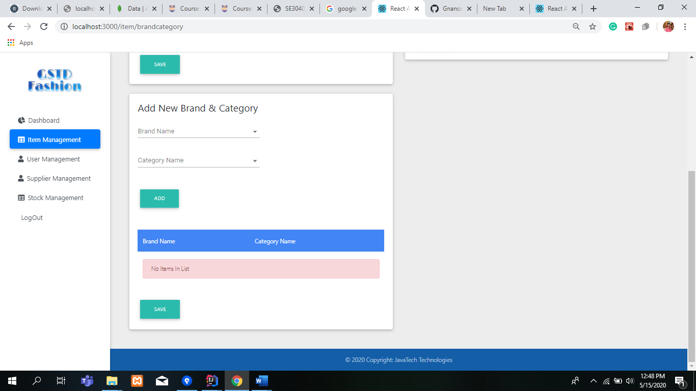

Brand and category Management function is responsible for keep tracking on Brand and Category Details. Only admin can add this details to the database.

In the Add new brand section admin can add brand details to the database. In the Add new category section admin can add category details to the database. In the add new brand & category section admin can choose brand name and category name using AutoComplete. After selecting brand name and category name he/she want to press add button. Then brand name and category name are added to the table after that. Finally, he/she want to press save button to add this details to database.

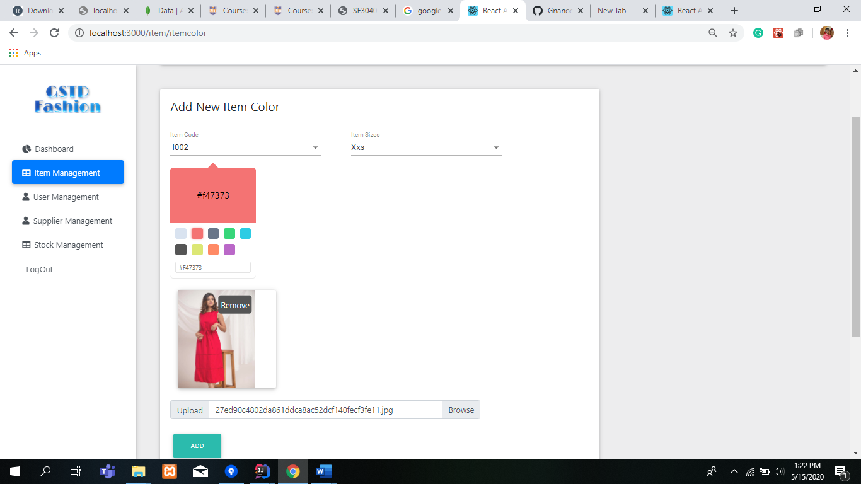

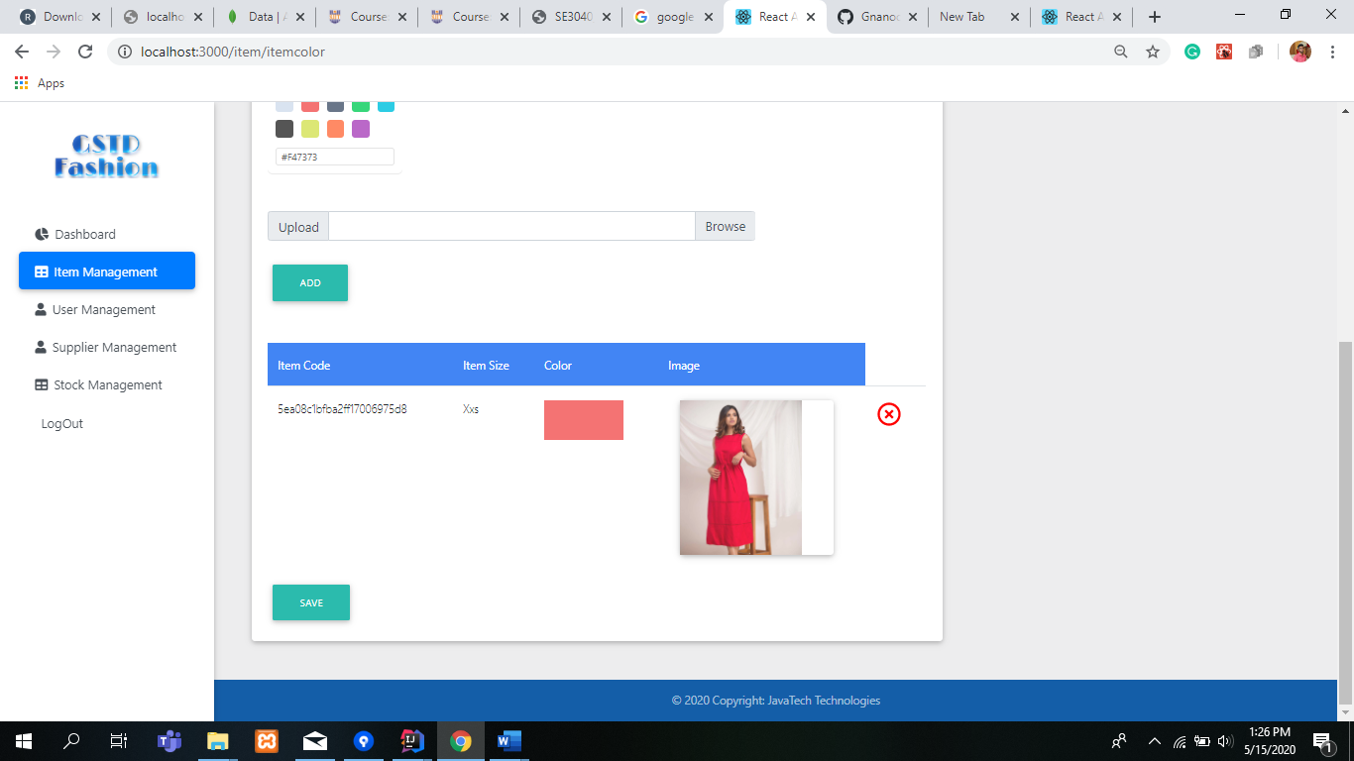

Item Color Function is responsible for keep tracking on Item colors according to Item. Store manager can select the Item code using Auto Complete. (Auto Complete have all Item Codes). Store Manager want to choose item Size, item Color using color chooser, and also he/she want to select item photo using file chooser. After that store manager wants to click add button to add this details to below table. After that he want to press save button to save this details.

**New Arrivals**

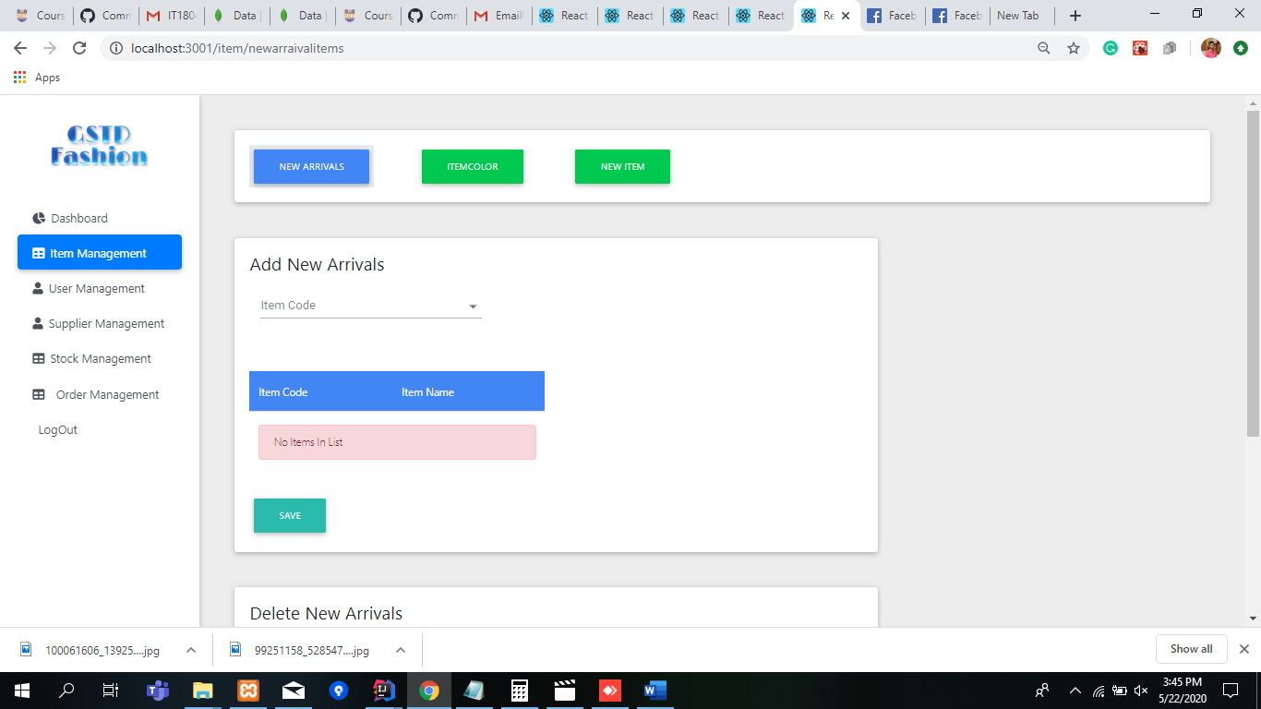

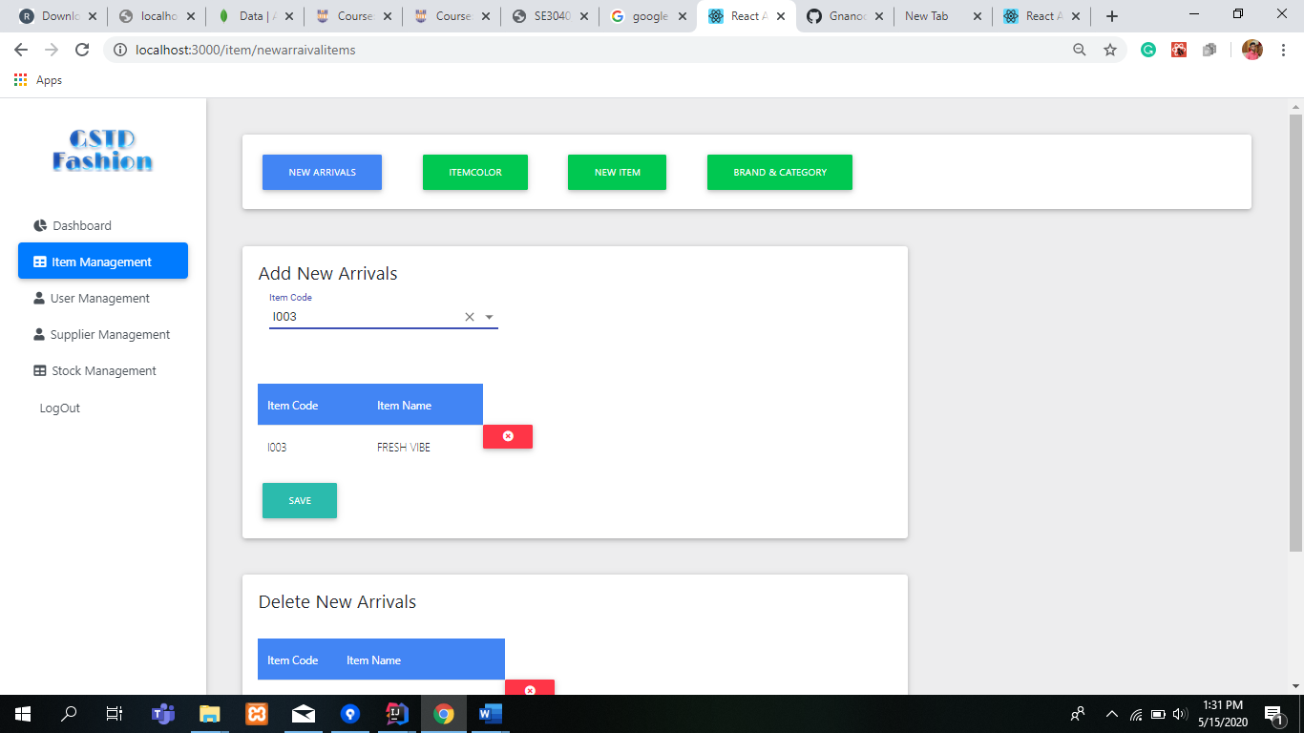

New Arrivals Item Management function is responsible for keep tracking on New Arrival Item Details. Admin and Store Manager can add this details to the database. Also, admin or Store manager can Delete the new Arrival items in the database.

**Home Page**

In the home page/landing page new arrival items are displayed. Along with that categories are shown. Once a new arrived item is added by the store manager it will automatically displayed in the home page. All new arrival items are displayed automatically according to the standards given.

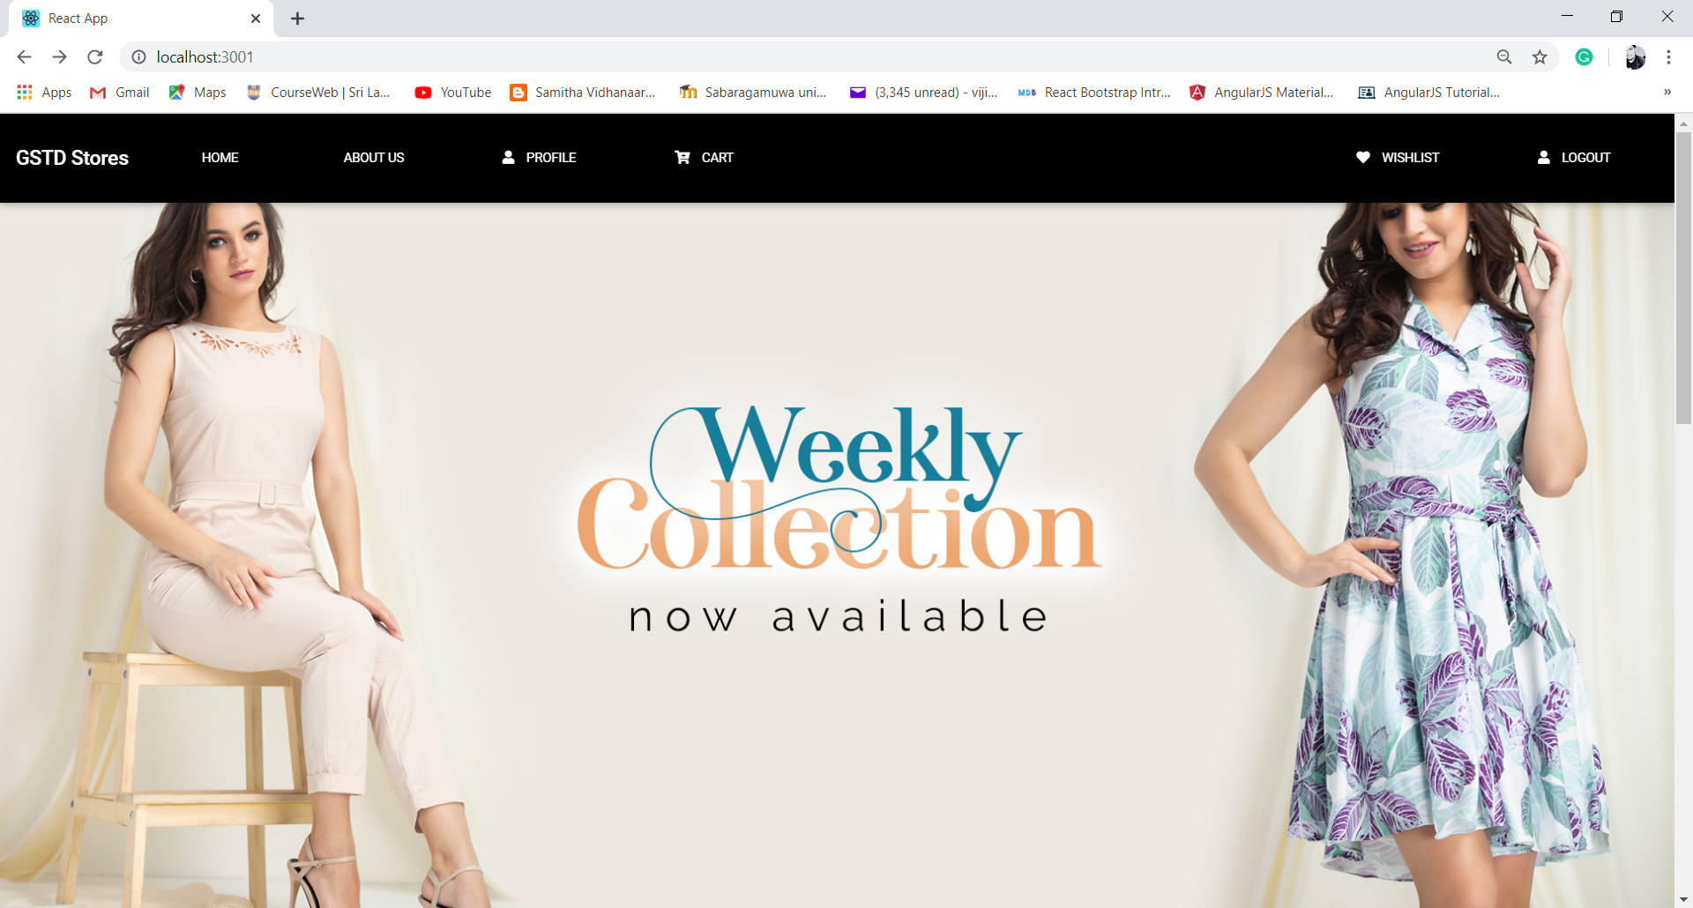

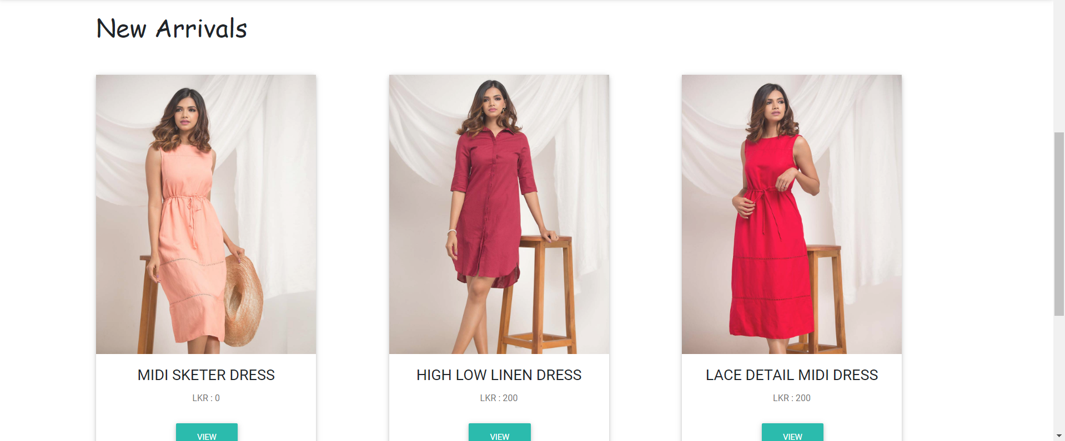

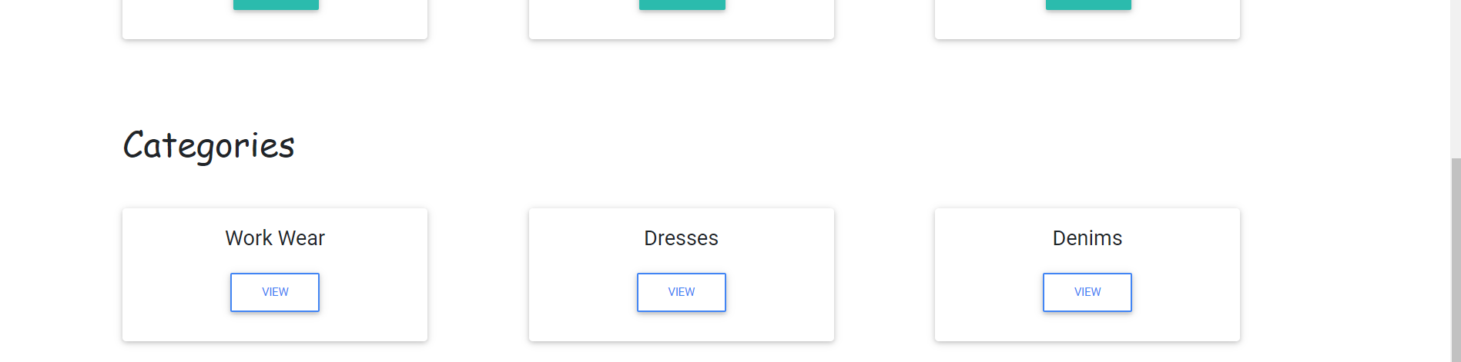

**Category Item Page**

Once the user clicks on a specific category, system automatically filters the data and display all the items from that category. Once a new arrived item is added by the store manager it will automatically displayed in the home page. All new arrival items are displayed automatically according to the standards given.

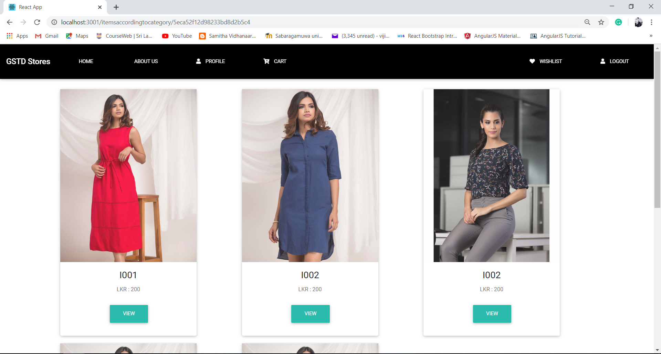

**Item Details Page**

When a customer clicks on an item it will direct to a page that shows the item in detail. If customer is not logged into the system it will not display the options to add items to the cart, add items to the Wish list, and add customer ratings and feedbacks

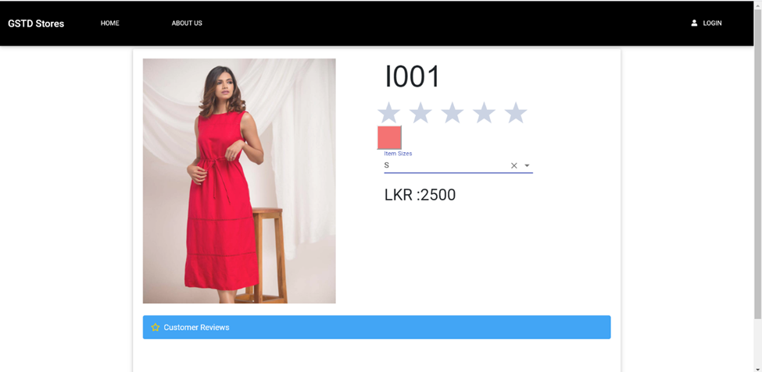

If customer has logged in to the system he/she can view options to add items to the cart, add items to the Wish list, and add customer ratings and feedbacks

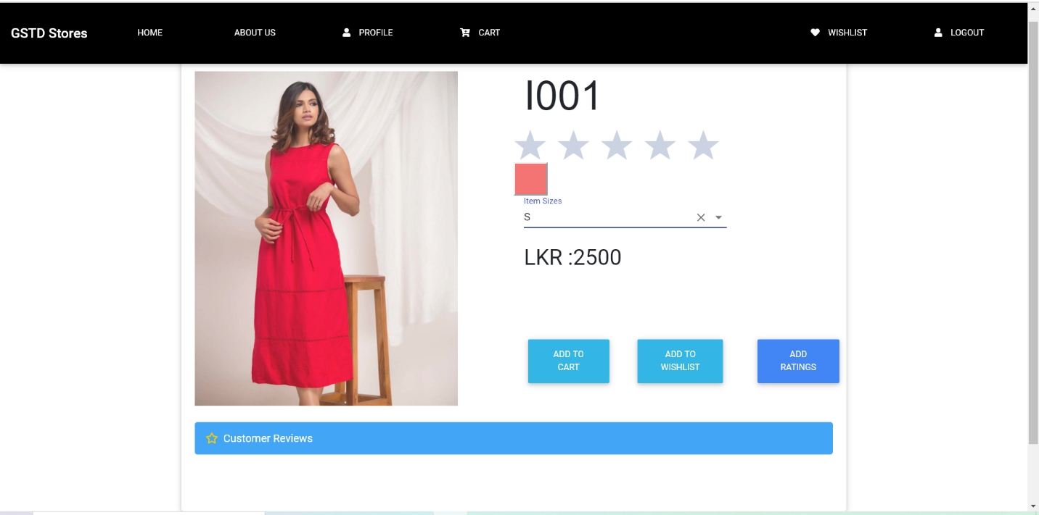

Then customers can select items as per their wish. To add item to Wish list/cart customer must enter the size and system shows the price of that item.

Customer can add feedbacks and ratings to an item and it is displayed in the item details page

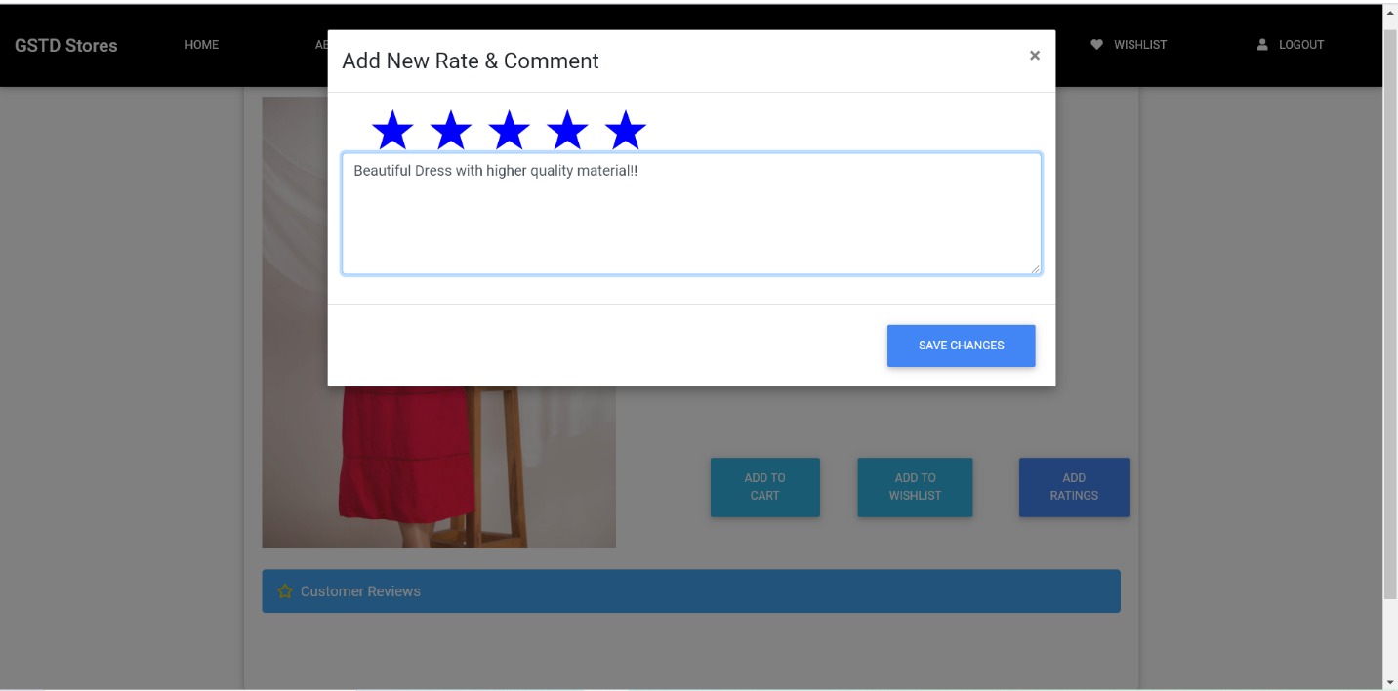

After adding a rating and a comment a success message is displayed.

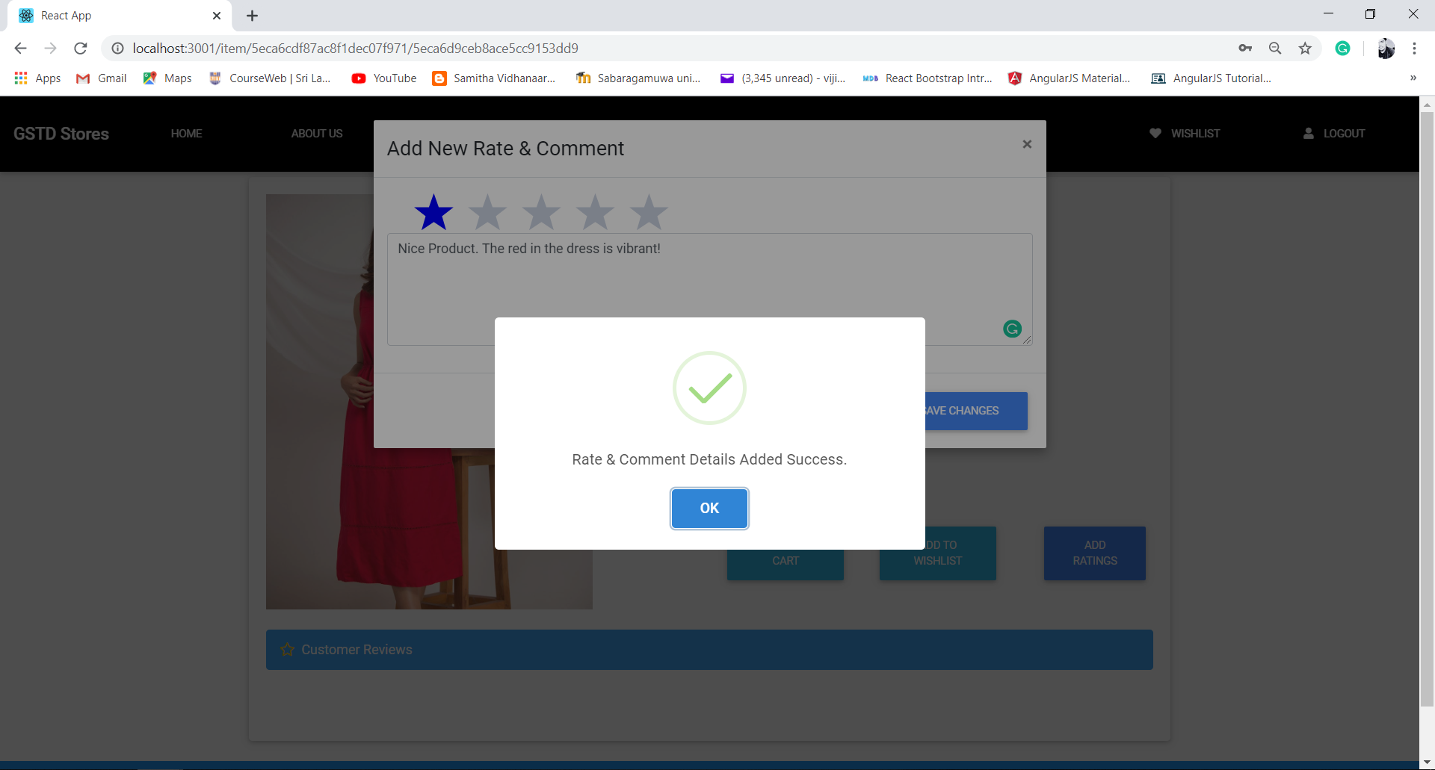

Now the added comment with the rating is indicated at the bottom of this page as customer reviews.

# **Order Management**

Order Management is a main component in the system as it has to keep track of the orders. Order management is the process of efficiently tracking sales and fulfilling online sales orders that are happening through the GSTD Store website.

In Order Management Component there 5 main functions as following,

* Add item to Cart & Wishlist
* Add item to Wishlist
* Manage Product Cart
* Mange User Wishlist
* Checkout the Order
* Manage Orders (Admin)

**Add item to Cart**

Once the customer logged in to the system, he/she can add items to the Product Cart list for instant purchasing. Only authorized customers who are logged into the system can see the option of adding item to the cart.

To add item to the cart, first user must select the size. (Size Validations) Then system checks whether requested item is available on the stock. (Stock Validations) If item is available, it is added to cart otherwise it will automatically generate a message indicating that item not available at the moment. When the requested item is adding to the cart system reserves that item for that user by decrementing one item from the available quantity of that item stock.

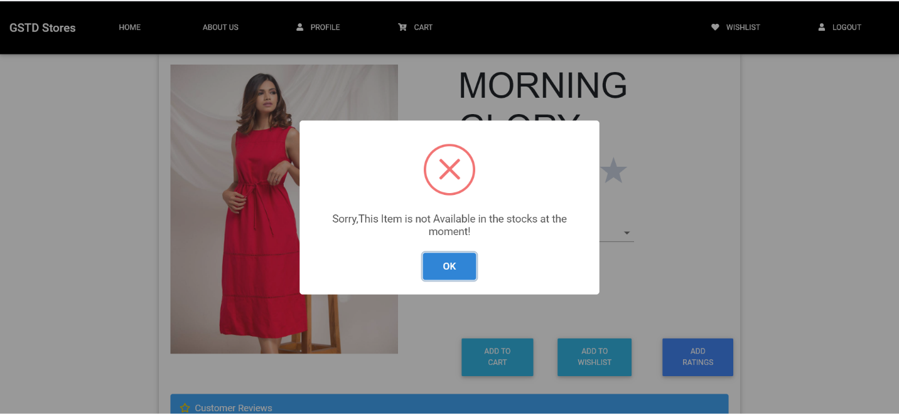

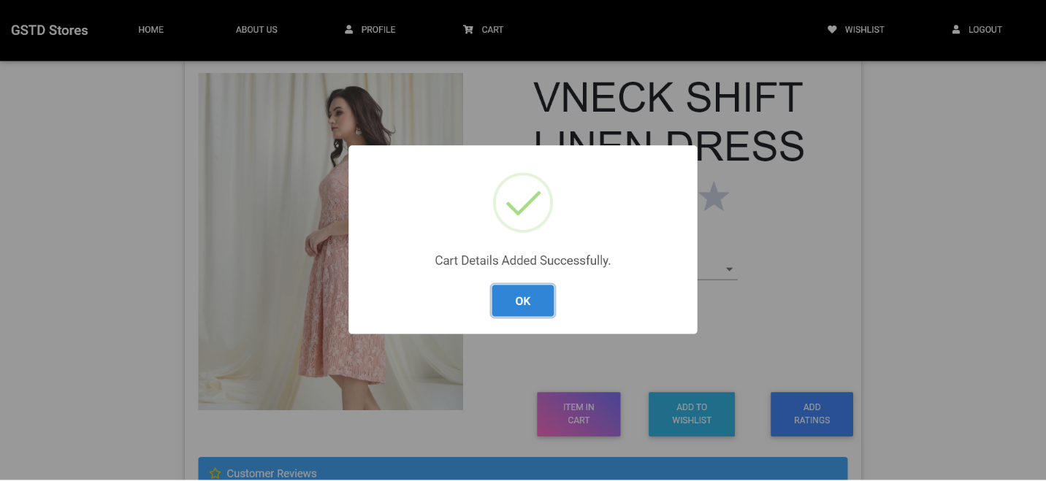

Once the item is added to cart it can’t be added again because system replaces the ‘add to cart’ option with ‘item in the cart’ option. (By checking the available items in the cart with current item’s id, item’s size, and logged user’s Id and updating in cart status)

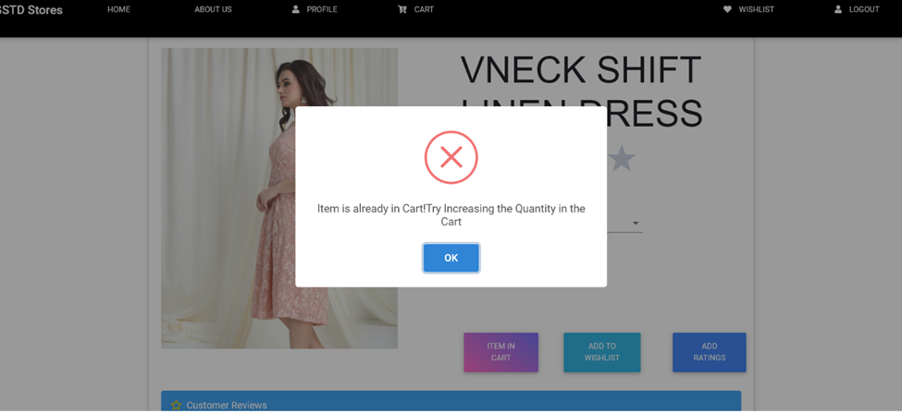

**Product Cart**

Customers / users can add item to the Product cart for purchasing. Items that have been added to the cart are displayed as a list of items and they are given the opportunity to increase/decrease item quantities and remove specific items as per customer’s wish.

Each item is given a discount by the store when adding an item. Once an item is added to the cart discount, price of the item, and actual amount to pay for each item is displayed. ((Price*quantity)-(discount*quantity)) And the summation of each item total is calculated as the total price.

Sub Total is the amount that of items that are in the cart without considering the discounts. Total Discount is indicated as the summation of each item’s discount. Total is the actual amount that customer has to pay that is calculated from subtracting discount from sub-total.

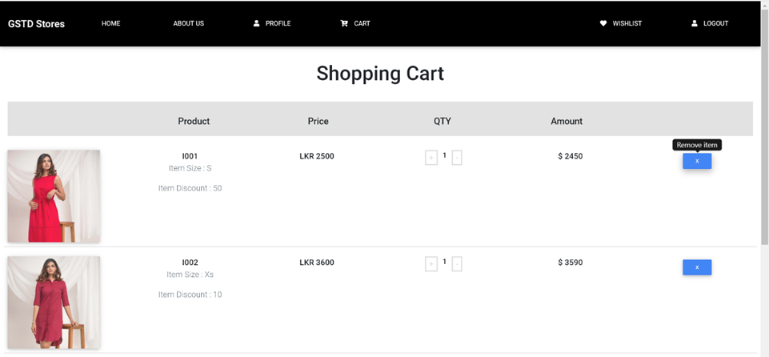

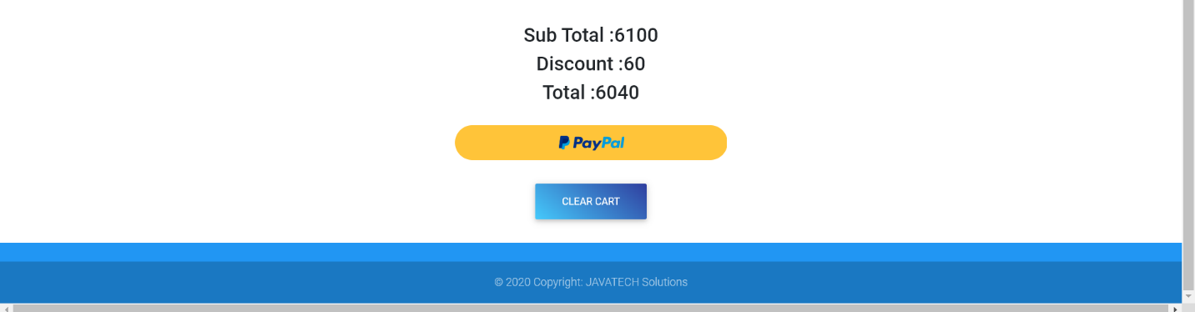

**Checkout the Order**

Once the customer wishes to purchase the items in cart, he/she can on the click on ‘PayPal Checkout’ option to check out the order. Here a sandbox PayPal account is used for integration. The PayPal sandbox is a self-contained, virtual testing environment which simulates the environment of live PayPal development. PayPal API is used to make the payment success. Users can pay with their PayPal account. PayPal button is used after installation for the project. (npm install –save react-paypal-express-checkout). Here the Total amount is passed as a parameter to PayPal API as the amount to be paid.

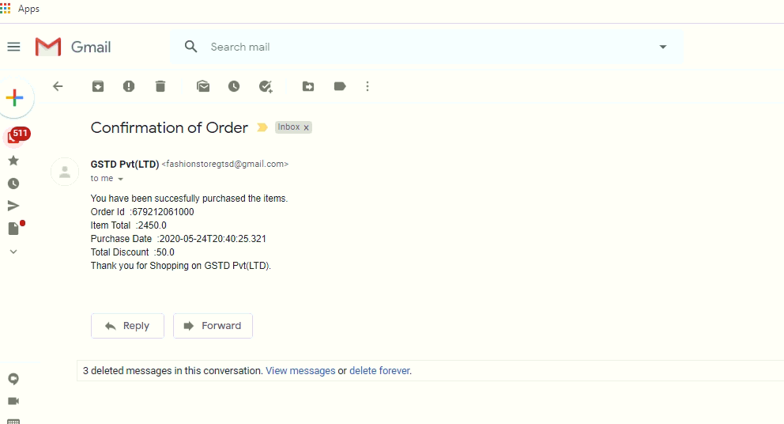Once the order is succeeded automatically customer will receive an email to his/her given mail address mentioning that order has been successfully placed.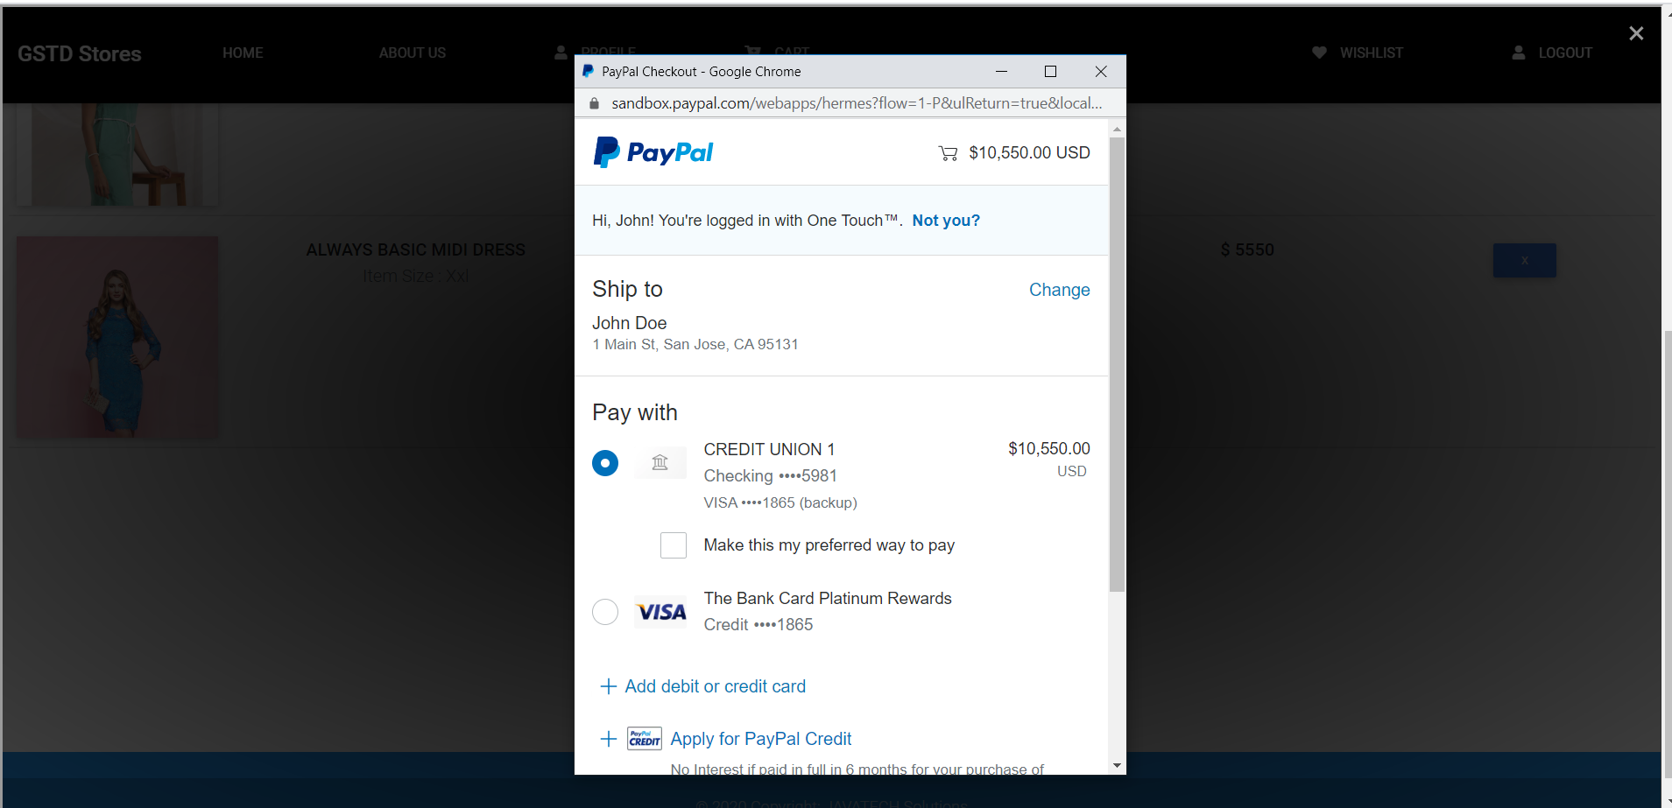

**Add item to Wishlist**

Once the customer logged in to the system, he/she can add items to the Product Wishlist for future purchase. Only authorized customers who are logged into the system can see the option of adding item to the Wishlist. To add item to the Wishlist, first user must select the size. (Size Validations). Then, it is added to the Wishlist.

Once the item is added to the Wishlist it can’t be added again because system replaces the ‘add to Wishlist’ option with ‘item in the Wishlist’ option. (By checking the available items in the Wishlist with current item’s id, item’s size, and logged user’s Id and updating in cart status).

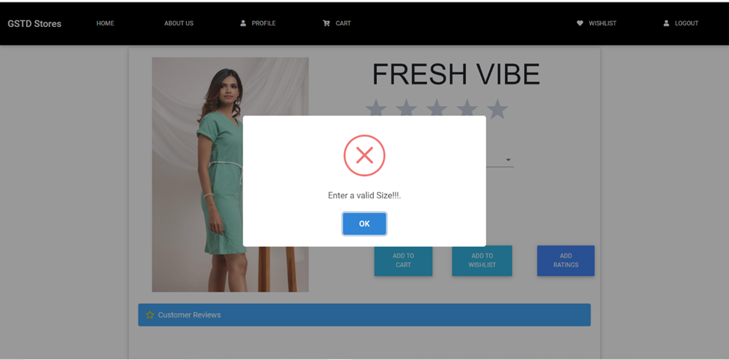

**Product Wishlist**

Customers can add item which he/she like to buy in the future to the Wishlist to make them remember. Whenever use feels to purchase them he/she can add Wishlist items to the cart if they are available at the moment. And also, users can remove items anytime as per customers wish.

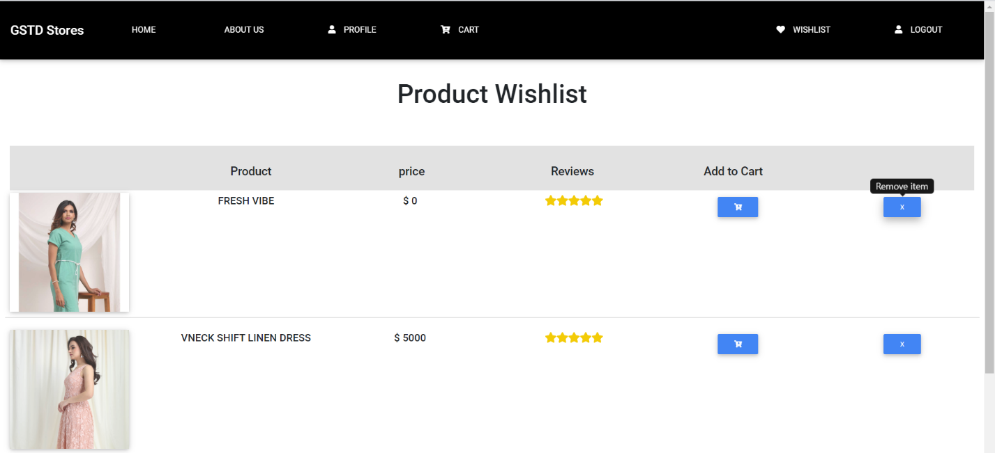

If the item is already in the cart it can’t be added again from Wishlist

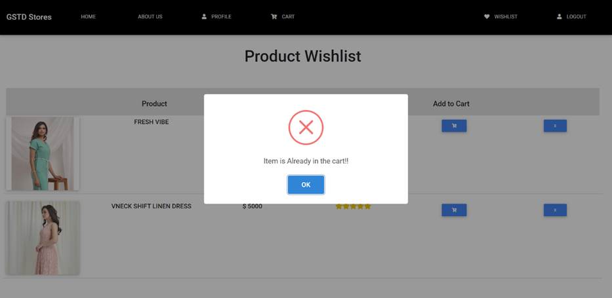

**Manage Orders (Admin panel)**

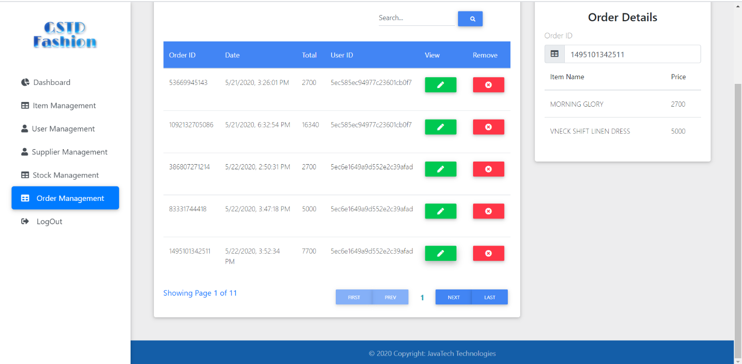Admin must login to the system to view Order details. Admin can view the order that has been succeeded with respect to their date of purchase and order Total. Here all the orders are displayed in a table and for the table implementation pagination techniques have been used. These items can be removed manually if admin wants.

If admin wants to view the items that have been purchased in a specific order admin can click on the view button and the item are displayed in an order details card along with the order Id

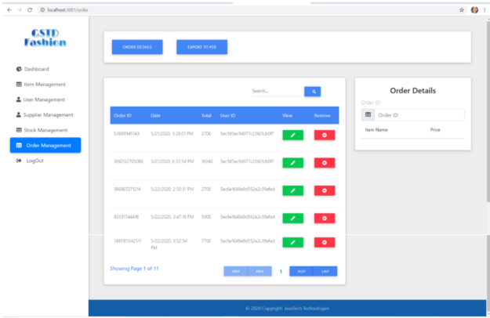

Admin can generate pdf reports of orders that have been succeeded once he/she click on the ‘Export to PDF’ button. (Here we have used ‘jspdf’ libraries to generate pdfs.

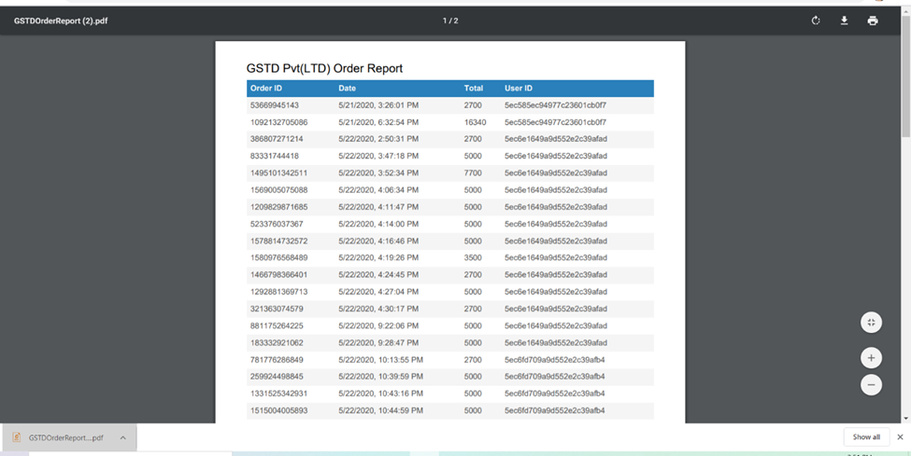

And total sales are calculated in dashboard and displayed as reports.

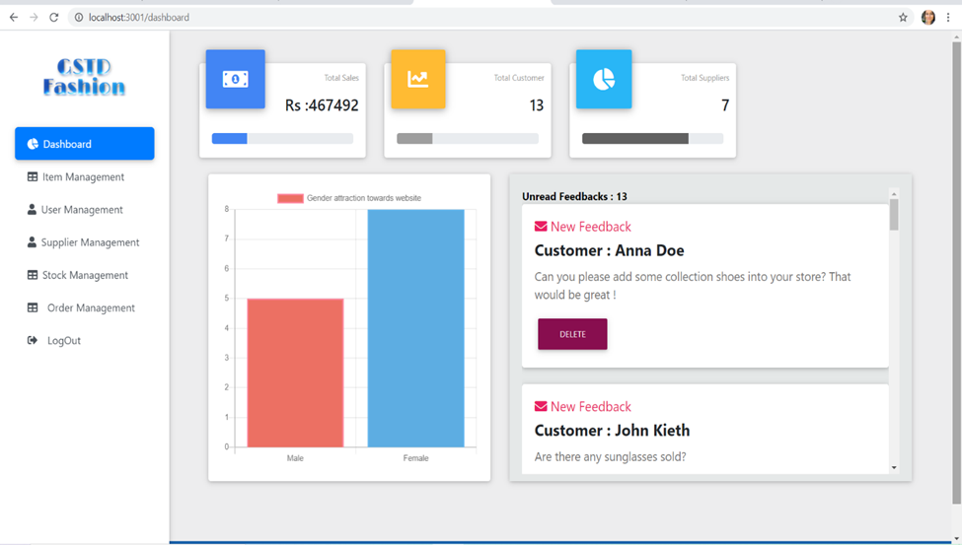

**Assumptions of Order Management**

* When customer add an item to the cart that item must be kept reserved for that user since, once the customer adds an item to the cart the stock quantity of that item is decreased by one.
* Then when the user increments /decrements the quantity it will work same as the above.
* But when an item is added to Wishlist stock is not decrementing because system can’t assure whether customer willing to buy that. As a solution when an item added to cart from Wishlist system automatically checks whether the item is available at the stock if available, the add item to the cart by decrementing the stock quantity.
* Customer can’t add items to cart/ Wishlist without selecting the size because size is variable factor.

# **Stock Management**

Stock management is mainly responsible for keep tracking supplier details and stock details. In stock management it contains some main functions like,

1. Add Suppliers.
2. Manage Suppliers.
3. Add Stocks.
4. Add Stock Details.
5. Add Stock Prices.
6. Manage Stocks.

**1.Add Suppliers**

The Store Manager can add details of suppliers by using below form. All the fields are validated and when user entered invalid values system will generate an error message to re-enter values, as well as all the fields should not be empty. If there is remaining empty fields, system will generate a message to the user and cannot be save details without filling relevant fields.

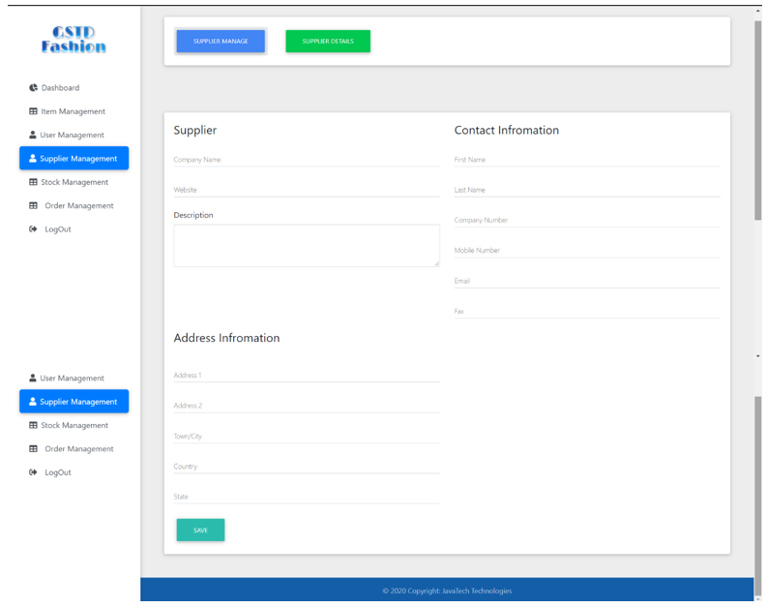

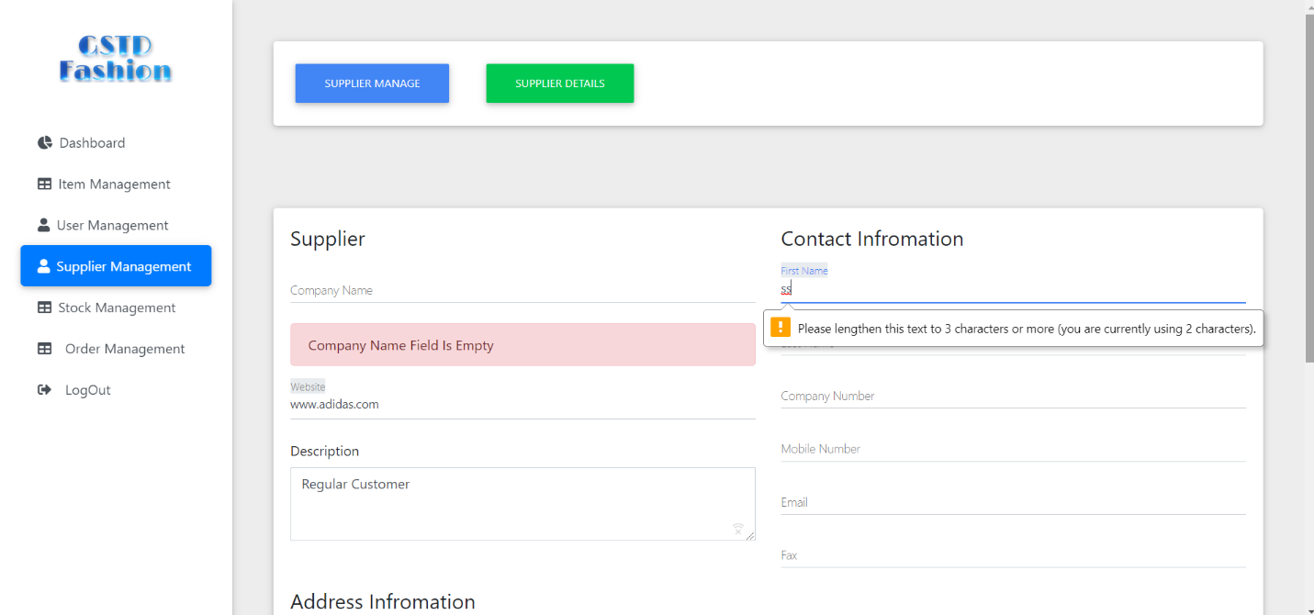

**2. Manage Suppliers**

The store manager can see all the registered suppliers in the table.

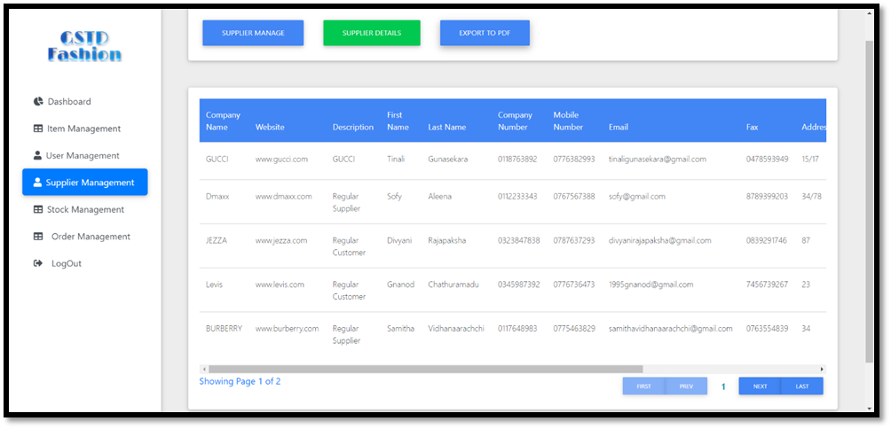

If store manager wants to delete suppliers, then he/she can delete the relevant row by click on the delete button

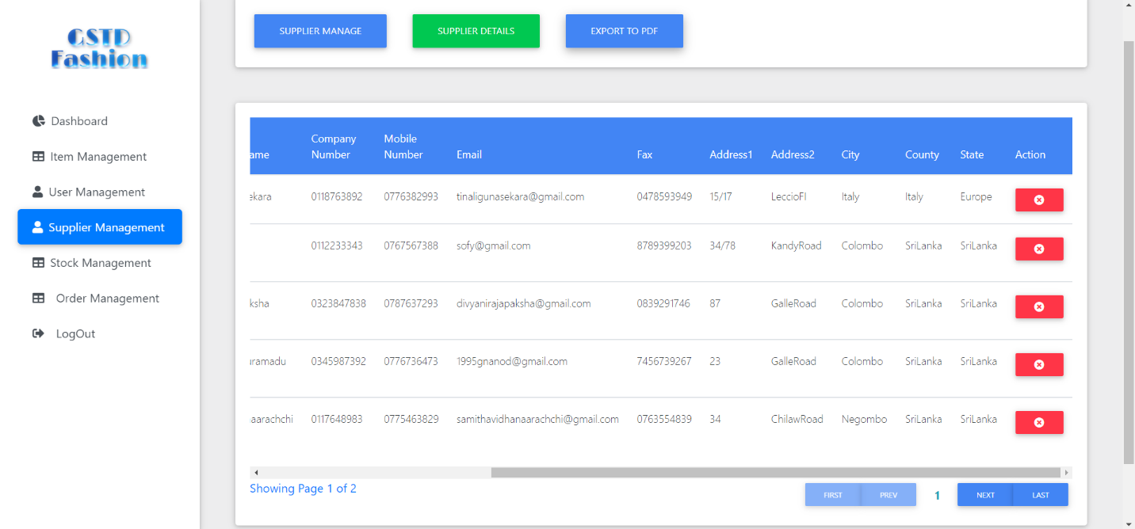

* 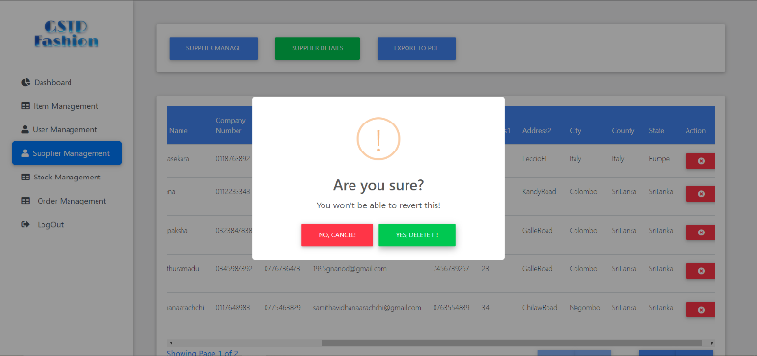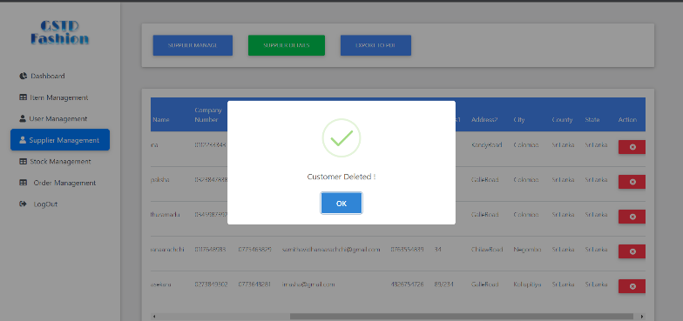When the store manager clicks on delete button, system will ask to confirm the action. After system will display a sweet-alert to show whether the action is success or not
* If store manager wants to generate a report of currently available suppliers, then he/she can get a report of suppliers as a pdf by click on EXPORT TO PDF button.

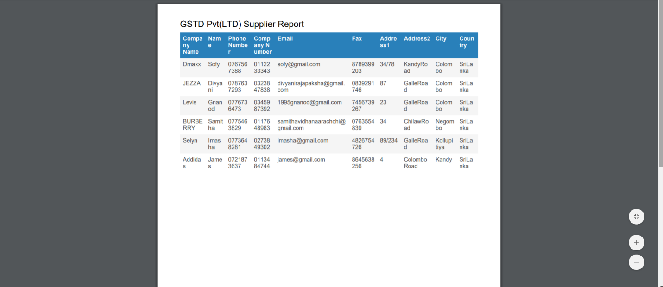

**2.Add Stocks**

This function responsible to get stock details and add them to the database. I used to get this information through one form shown as below

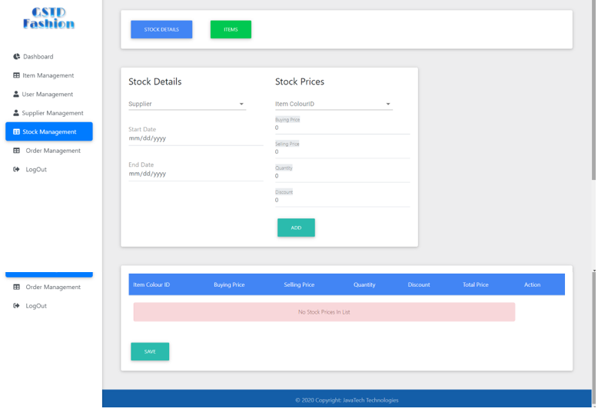

• Store manager can add many items with stock prices to a one particular supplier. In this form there are two parts to fill. First, manager should have to select a supplier, start date and end date. In here I used autocomplete to get all the suppliers from the supplier table and to show them in a dropdown.

• In the second part of the form store manager can select item color ID and can add buying price, selling price, quantity, and the discount for the stock. In item color ID field also use an autocomplete to get item color ID from the item colors table and to show them in a dropdown.

• All the fields are validated in this stock form. If user add invalid values and keep fields empty, then system will show a message about informing that.

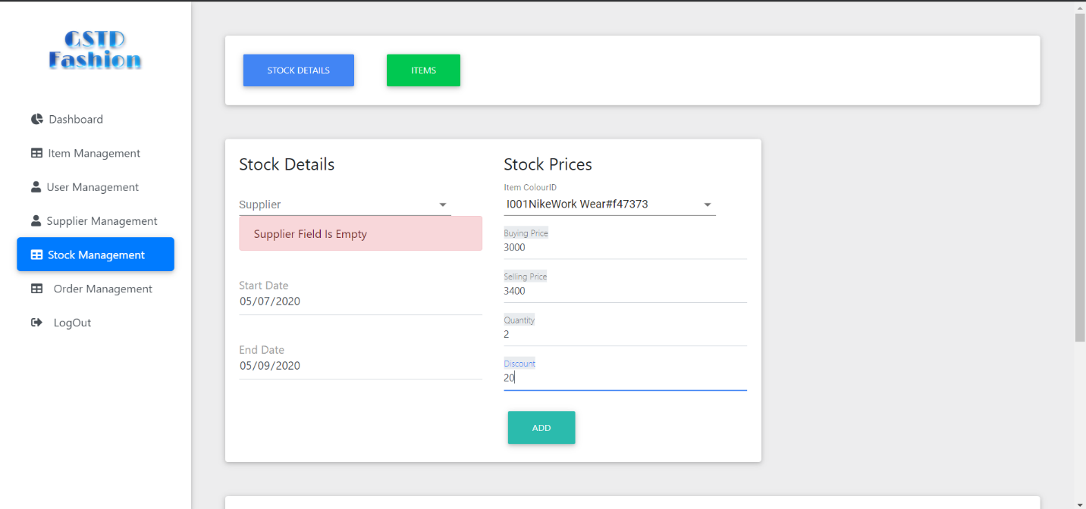

• When manager add stock details to the table, then system will automatically calculate the total price of each item by multiplying the quantity and the buying price.

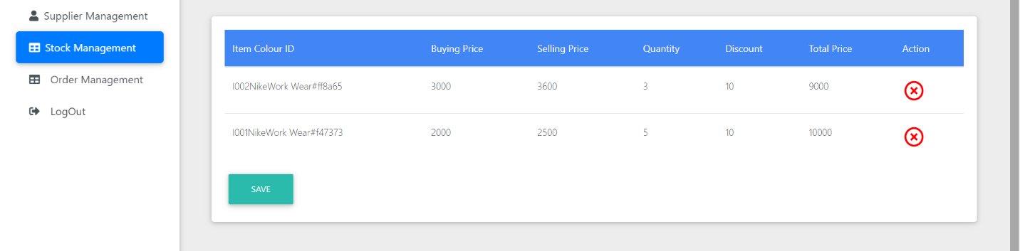

* **Assumption:** One supplier can have many items. So that I did not display supplier details in the table. Because the same value repeated in each row. If store manager wants to add new items from a new supplier, then he/she can fill the form same as I describe above.
* If store manager can delete items which are added to the table by click on delete button.
* After added stock prices to the relevant items, manager can submit all details to the database by click on submit button. Then all the stock details are saved in the stock table and the other entered stock prices are saved in a separate table called stockPrices. These two processes are occurred simultaneously.
* As well as, when manager click on the save button simultaneously system will update current quantity and the selling price into new values in the itemcolor table. Not only that but also in the same moment system will calculate the sum of all the total prices of items and display that value in the stocks table as full total price.
* 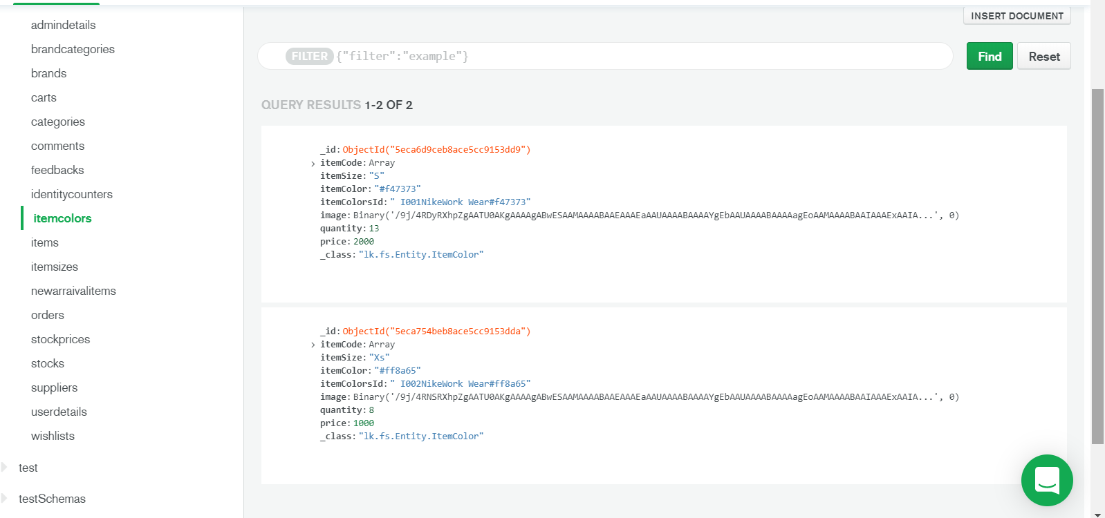**Before update the table**
* 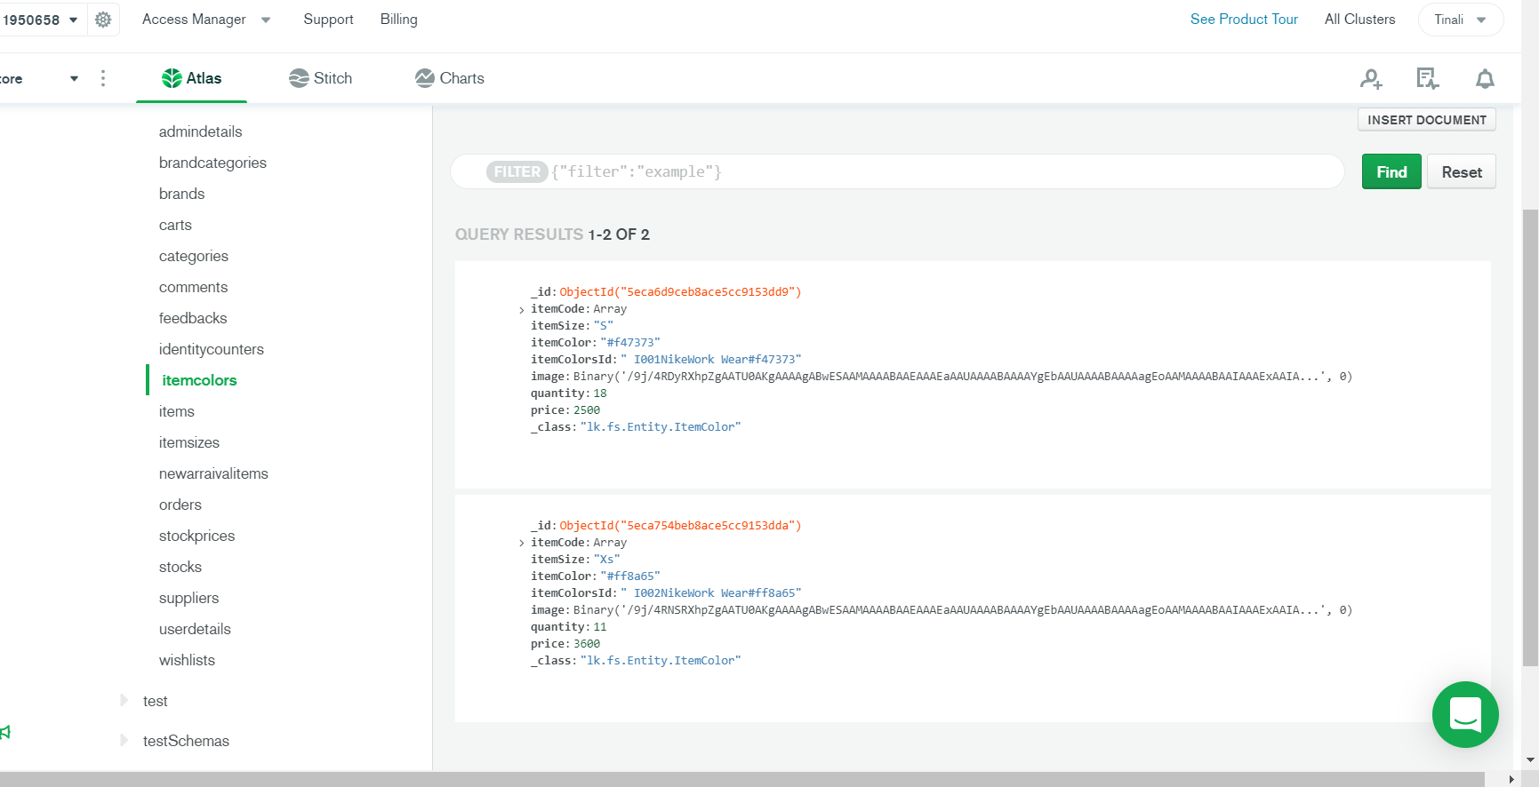**After updated the table**
* 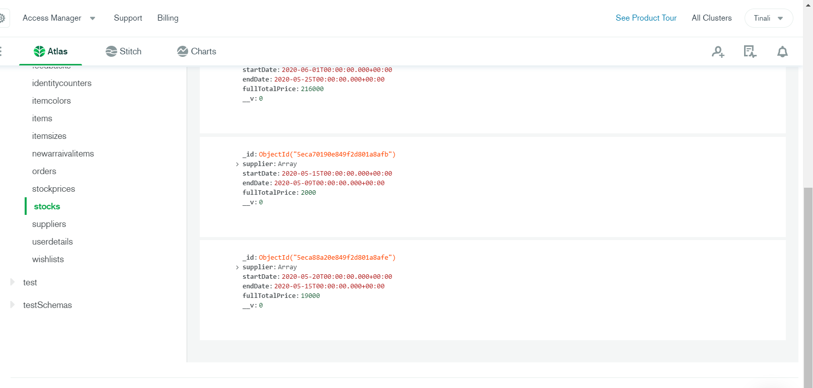**Display calculated full total price as below in the stocks table**.

**Manage Items**

* 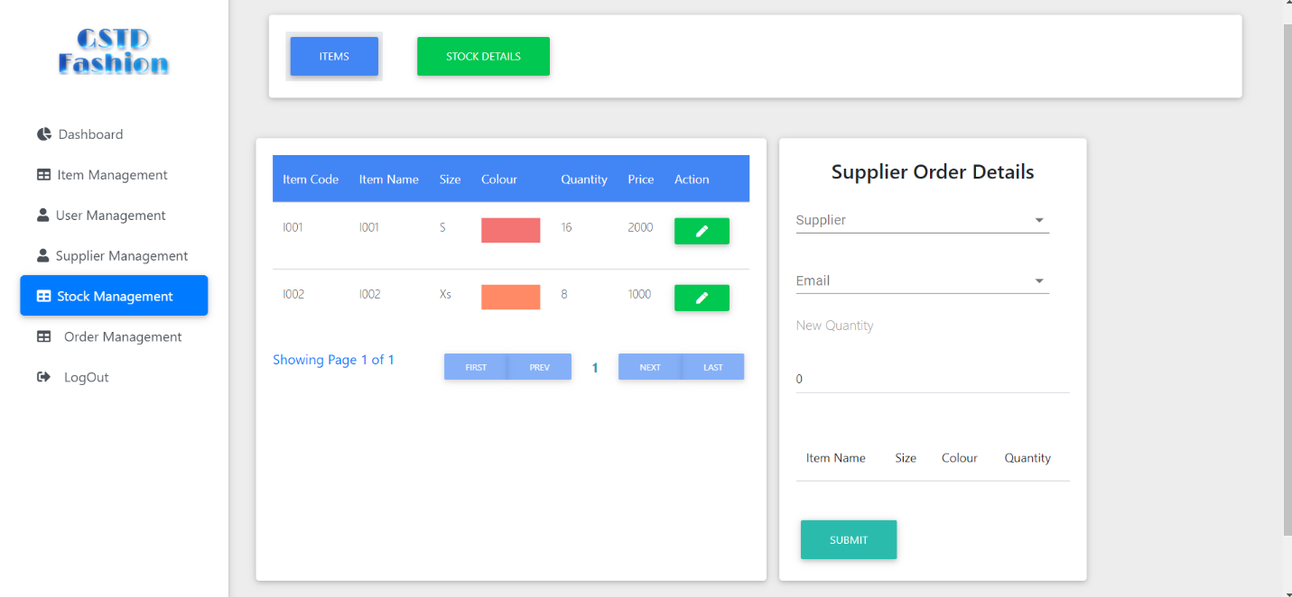Store Manager can view details of items in a table as below.
* By considering the quantity of the items, store manager can send emails to the specific suppliers. This can do by filling the form of supplier order details.
* Supplier order details contain with fields like supplier, email, new quantity

and a small table about the items. I used autocomplete for supplier and the email to get currently available suppliers and their emails from database. When store manager click on the ‘edit button’ shows in the item table, then according to the unique id that specific details will display in the small table of the Supplier order details form. After user can choose the supplier, email and can add new quantity. After filling all the details manager can click on submit button to send mail to relevant supplier. Then system will generate an alert about saying whether the email sent or not.

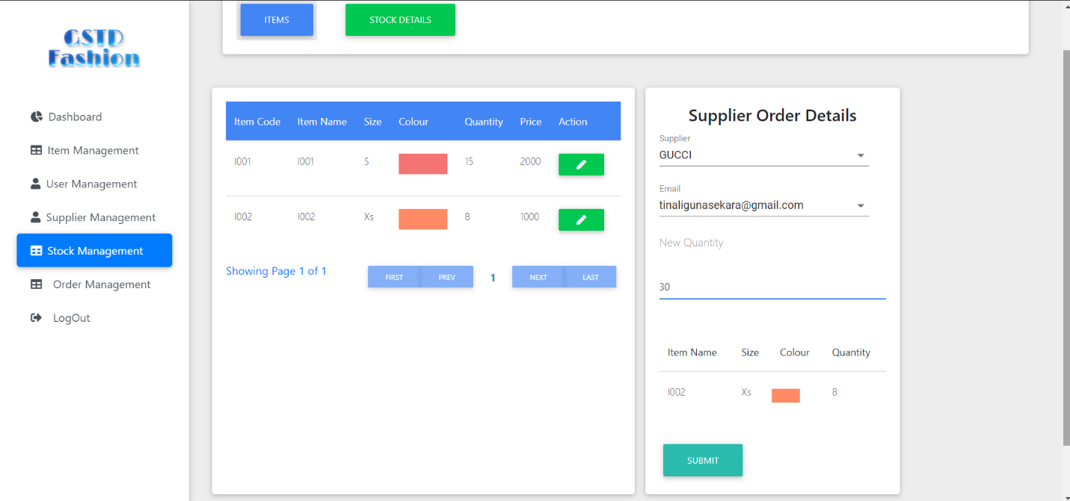

**Assumptions: This can generate automatically to send emails by checking the quantity of the items. But in here I used a form to send mails because of a special reason. When we have suppliers that we do not want to get products anymore from them. If that item’s quantities are less, then automatically sent mails to them also. To avoid that I used this way to send mail for suppliers.**

* System will display an alert when mail has sent successfully.

